西 南 交 通 大 学
本科毕业设计（论文）

Research and Design of Embedded EIS Measurement System for Lithium-ion Batteries

年 级: 二〇二二级
学 号: 2022115937
姓 名: 刘新哲
专 业: 电子信息工程

指导老师（签字）:
时间：二〇二六年五月

School of Electronic and  Electrical Engineering  FACULTY OF ENGINEERING | 

XJEL3875

Project Report

Research and Design of Embedded EIS Measurement System for Lithium-ion Batteries
XINZHE LIU

SID: 201691164 | Project No: 40
Supervisor: JIN SHA | Assessor: SHUNFENG YANG

School of Electronic and  Electrical Engineering  FACULTY OF ENGINEERING |  |  |  | 
XJEL3875 Individual Engineering project

Declaration of Academic Integrity

Plagiarism in University Assessments
and the Presentation of Fraudulent or Fabricated Coursework

Plagiarism is defined as presenting someone else’s work as your own. Work means any intellectual output, and typically includes text, data, images, sound or performance.

Fraudulent or fabricated coursework is defined as work, particularly reports of laboratory or practical work that is untrue and/or made up, submitted to satisfy the requirements of a University assessment, in whole or in part.

Declaration:

- I have read the University Regulations on Plagiarism ^{[1]} and state that the work covered by this declaration is my own and does not contain any unacknowledged work from other sources.
- I confirm my consent to the University copying and distributing any or all of my work in any form and using third parties (who may be based outside the EU/EEA) to monitor breaches of regulations, to verify whether my work contains plagiarised material, and for quality assurance purposes.
- I confirm that details of any mitigating circumstances or other matters which might have affected my performance and which I wish to bring to the attention of the examiners, have been submitted to the Student Support Office.
[1] Available on the School Student Intranet

Student Name: |  | XINZHE LIU | Project No. |  | 40
Signed: |  |  | Date: |  | 2026.4.22

Project Report Wordcount: (introduction, technical chapters, conclusion and reflection, which excludes abstract and list of references) | 20262
OneDrive Link to Video Demonstration:
https://leeds365-my.sharepoint.com/:v:/g/personal/el22xl2_leeds_ac_uk/IQCRTZ_ONT3hQoQi0UQoVVOiAWNDsQX8mr9iafrWQpg16ik?nav=eyJyZWZlcnJhbEluZm8iOnsicmVmZXJyYWxBcHAiOiJPbmVEcml2ZUZvckJ1c2luZXNzIiwicmVmZXJyYWxBcHBQbGF0Zm9ybSI6IldlYiIsInJlZmVycmFsTW9kZSI6InZpZXciLCJyZWZlcnJhbFZpZXciOiJNeUZpbGVzTGlua0NvcHkifX0&e=2707L4

Document Name | Date and Means of Approval
Review Document 1 | 2025.10.20, X10838, Offline Meeting
Review Document 2 | 2025.10.27, Online
Review Document 3 | 2025.11.10, Online
Review Document 4 | 2025.11.18, Online
Review Document 5 | 2025.11.24, Online
Review Document 6 | 2025.12.01, Online
Review Document 7 | 2025.12.08, Online
Review Document 8 | 2026.03.01, Online
Review Document 9 | 2026.03.15, Online
Review Document 10 | 2016.04.01, Online

西南交通大学
本科毕业设计（论文）版权使用授权书

本毕业设计（论文）作者同意学校保留并向国家有关部门或机构送交论文的复印件和电子版，允许论文被查阅和借阅。本人授权西南交通大学可以将本毕业设计（论文）的全部或部分内容编入有关数据库进行检索，可以采用影印、缩印或扫描等复制手段保存和汇编本毕业设计（论文）。
保密□，在 年解密后适用本授权书。
本论文属于
不保密☑。
（请在以上方框内打“√”）

作者签名：  指导教师签名：

日期： 年 月 日 日期： 年 月

Abstract
In recent years, lithium-ion batteries have been widely used in electric vehicles and small electronic devices. The battery management system (BMS) of lithium-ion batteries can accurately monitor the state of charge (SoC) and state of health (SoH) of the battery in real time, which is crucial for ensuring battery safety and extending its service life. [2][3][8][9] Traditional battery state monitoring methods, such as coulomb counting, open-circuit voltage (OCV), and model-based filter estimation, have many limitations, such as error accumulation, long waiting time, sensitivity to model component mismatch or aging, and difficulty in maintaining high accuracy over long periods under dynamic conditions. [2][9][14][19] Electrochemical impedance spectroscopy (EIS) testing can obtain broadband impedance information through millivolt-level small signals. Since the impedance values of lithium batteries at different frequencies are related to the internal electrochemical reactions of the battery, impedance spectra can provide more abundant "battery fingerprint" information and can be used for online monitoring. [1][5][6][7] This paper proposes an online EIS measurement and SoC estimation scheme for built-in BMS based on a single-chip microcomputer: using an embedded system to inject small signals into lithium batteries, collecting voltage/current signals in the 5Hz-2kHz frequency band, and extracting complex impedance shapes and key parts through the FFT algorithm. [3][4][10][11] A battery and small signal injection/measurement chain model was established in MATLAB/Simulink to verify key parameters such as impedance, response amplitude, frequency, and phase. The goal is to achieve observable measurement of milliohm-level impedance changes with a small fluctuation of about 4mW. [3][6] The expected results include a replicable EIS test platform, impedance-SoC mapping, and detection steps, providing a feasible method for low-cost online battery state perception and charging strategy control. [1][9][13]

Keywords: Lithium-ion battery, Electrochemical impedance spectroscopy, Embedded measurement, SoC estimation, Equalization control

Acknowledgements
I would like to express my sincere gratitude to my supervisor, Ms. Jin Sha, for her continuous guidance, support, and encouragement throughout this individual engineering project. From the initial selection of the research topic to the later stages of modelling, simulation, result analysis, and report writing, her advice helped me gradually clarify the technical direction of this project and improve the overall structure of my work. Her suggestions not only helped me better understand the relationship between embedded EIS measurement, lithium-ion battery modelling, and control strategy design, but also encouraged me to think more carefully about the engineering feasibility and limitations of the proposed system.
I would also like to thank Mr. Shunfeng Yang, the assessor of this project, for his time, careful review, and constructive feedback. His comments provided useful perspectives for improving the quality, clarity, and academic presentation of this report. The feedback received during the project process helped me identify areas that required further explanation and refinement, especially in relation to the simulation results and the interpretation of system performance.
In addition, I am grateful to the School of Electronic and Electrical Engineering at the University of Leeds and Southwest Jiaotong University for providing the academic environment, learning resources, and project framework that supported the completion of this work. The knowledge gained from previous modules in electronics, control systems, signal processing, and embedded systems provided an important foundation for carrying out this project. Through this process, I was able to connect theoretical knowledge with practical engineering analysis and develop a deeper understanding of battery management systems and impedance-based state estimation methods.
I would also like to thank my classmates and friends who offered useful discussions, suggestions, and encouragement during the project. Their support helped me maintain motivation when facing difficulties in simulation modelling, debugging, and report preparation. Finally, I would like to express my deepest appreciation to my family for their constant support, patience, and understanding throughout my studies. Their encouragement has always been an important source of confidence for me.
This project has been a valuable learning experience. It has improved my ability to conduct independent research, analyse engineering problems, and present technical work in a structured manner. I am sincerely grateful to everyone who has supported me during this project.

Table of Contents

Declaration of Academic Integrity I
Abstract I
Acknowledgements II
Table of Contents III
List of Figures V
List of Tables VI
Chapter 1 Introduction 1
1.1 Background 1
1.2 Literature Review 2
1.2.1 Background and Significance of Lithium-Ion Battery Application Research 2
1.2.2 State-Aware and Online Measurement Techniques Based on Impedance Spectra 2
1.2.3 SoC/SoH Estimation Methods Development: From Model-Driven to Data-Driven 4
1.3 Problem Definition and Objectives 5
Chapter 2 Embedded Lithium Battery EIS Measurement System Architecture 8
2.1 DC-DC Buck Converter 8
2.1.1 Buck Converter 8
2.1.2 Closed-Loop Control of the Buck Interface Converter 9
2.2 Architecture of the Embedded Lithium Battery EIS Measurement System 15
2.3 Control Strategy for the Embedded Lithium Battery EIS Measurement System 17
Chapter 3 Achievement and Simulation 20
3.1 Design of Parameters for the Embedded Lithium Battery EIS Measurement System 20
3.1.1 Switching Frequency and Sampling Frequency 20
3.1.2 Model Parameters 21
3.2 Simulation Model 25
3.2.1 Main Circuit Module 26
3.2.2 System Control Module 27
3.2.3 AC Excitation Current Frequency and Related Parameter Generation Module 28
3.2.4 Impedance Calculation Module 29
Chapter 4 Simulation Results and Analysis 31
4.1 Control Strategy and Its Simulation Results 31
4.1.1 Simulation Results Based on the PI Control Strategy 31
4.1.2 Simulation Results Based on the AC/DC Decoupling Control Strategy 34
Chapter 5 Conclusion and Future Work 38
5.1 Conclusions 38
5.2 Future Work 39
5.3 Reflection 40
References and Bibliography 42
Appendix A. Function Block Code 44
Appendix B. Progress Journal 55

List of Figures
1-1 Nyquist impedance plot of Samsung INR18650. 3
1-2 Block diagram of an embedded EIS measurement system 6
2-1 Operating current path of the Buck converter over one switching cycle 8
2-2 Amplitude-frequency response of closed-loop transfer function for embedded lithium battery EIS measurement system based on PI control 14
2-3 Architecture of embedded lithium battery EIS measurement System based on bidirectional Buck/Boost converter 16
2-4 Block diagram of PI-controlled embedded lithium battery EIS measurement system 18
2-5 Block diagram of the AC/DC decoupling control strategy 19
3-1 Main circuit module 27
3-2 System Control module 28
3-3 AC excitation current frequency and related parameter generation module 28
3-4 Impedance calculation module 29
4-1 Output current tracking waveforms based on PI control strategy at typical low and high frequency points 32
4-2 Output current tracking waveform based on AC/DC decoupling control strategy at typical high-frequency points 35

List of Tables
3-1 Parameters of the first-order equivalent circuit of lithium batteries and component parameters of bidirectional buck converters 24
4-1 Summary of impedance measurement results at selected frequency points 35

Chapter 1 Introduction

1.1 Background
The application fields of lithium-ion batteries are extremely extensive; ranging from electric vehicles to various small electronic devices, they are found almost everywhere. With the continued proliferation of electric vehicles, portable electronic products, and distributed energy storage systems, lithium-ion batteries have emerged as one of the most critical energy storage technologies, thanks to their high energy density, long cycle life, low self-discharge rate, and flexible system integration capabilities [8][9]. To ensure the safe and efficient operation of battery systems, it is particularly imperative to accurately estimate the State of Charge (SoC) in real-time and to implement effective State of Health (SoH) monitoring [2][3][7][9]. In practical engineering applications, inaccurate estimation of battery status can lead not only to improper charge-discharge control, reduced available capacity, and accelerated battery aging, but may even trigger serious safety hazards such as overcharging, over-discharging, and thermal runaway. Therefore, the precise monitoring and assessment of battery status constitute not merely an engineering requirement, but a fundamental safety assurance mandate that modern battery-powered systems must fulfill.
Battery Management Systems (BMS) must continuously monitor the battery's voltage, current, and temperature in real-time to prevent overcharging or over-discharging, thereby effectively extending the battery's service life [3][8]. On top of basic protection functions, a BMS also need to do cell balancing, charge control, find faults, lifetime management and energy optimisation. These jobs all need accurate knowledge of the battery's internal state. In these, state of charge (SoC) tell the remaining capacity of battery compared to its set or now use power, while state of health (SoH) show how much the battery got worse from its initial condition [3][8]. SoC is close to the system's run time left, but SoH link to power loss, increase in internal resistance and long-term reliability. So, SoC and SoH estimation are two big jobs in battery handle study.
Battery inside chemical energy cannot be measured directly, so sensor must take measure from outside to estimate SoC/SoH, that is a major challenge in BMS design [3][9]. Conventional estimation methods mostly use measurable external signals, like terminal voltage, current and temperature. For example, coulomb counting is easy to do but have problem from accumulated current measurement error and uncertainty in the initial SoC. The open-circuit voltage method have clear physics base, but it often need long rest time and so not good for real-time work under change load. Model filter ways can make dynamic estimation better, but their accuracy is touchy to battery model parameters, temperature change and age effects [9][19]. These limits show that outside time signals alone may not give enough info for strong state guess under complex operating conditions.
Electrochemical impedance spectroscopy (EIS) give a good extra way cause it show how battery act in frequency domain under small-signal excitation. The impedance response at different frequencies link to internal electrochemical processes, like ohmic conduction, charge transfer and diffusion behaviour [1][7]. Compared to just time-domain measurements, impedance features can give more info about battery internal state, which help for SoC guess, SoH diagnosis and fault detection. But, normal EIS measure often need special laboratory instruments and offline testing procedures, which stop its direct use in embedded BMS systems.
Therefore, an important research direction is to embed EIS measurement capability into the existing battery charging and management hardware. By reusing the power converter, current and voltage sensing circuits, and digital controller, it is possible to inject a small AC perturbation during the normal charging process and extract the corresponding voltage and current response for impedance calculation [3][4][6]. In this context, the embedded lithium battery EIS measurement system studied in this paper aims to combine power electronic control, signal acquisition and impedance extraction within a compact BMS-oriented framework.

1.2 Literature Review

1.2.1 Background and Significance of Lithium-Ion Battery Application Research
Electric cars, portable electronic devices, and energy storage systems have developed rapidly. Safe use, keep working, and know state of lithium batteries have received increasing attention. Some reviews say battery energy storage systems can do big jobs like real-time balance between supply and demand, support renewable energy integration into the grid. For cars, batteries affect power use, life, cost, and safe. So, high-accuracy state estimation become main thing in battery care [8][9]. Same time, more want for state check of lithium batteries push on test of impedance and state identification methods. A review say state of charge (SoC), state of health (SoH), and internal temperature (IT) are three key state things that impedance ways try to help [1].
For reliable state estimation, build test systems and battery models is also basic work. Previous studies have shown that big power car batteries under different conditions need highly repeatable measurements from auto test systems, with model parameters made from these measure data [13]. At model level, a kind of full electric battery model was put out, with nonlinear open-circuit voltage, power need on current, heat, cycle count, store time, and transient response. Check on different battery kinds show this model can guess run time and voltage-current characteristics more right [14]. This tell that battery state guess can't just use one guess way; it also need test platform repeatability, model validity, and work condition steady. For inside EIS measure, this point is very key, because the impedance features from voltage and current responses must be read on a real battery model and a same measure process. So, test place, with the same model, make big help for later SoC, SoH, and impedance feature extraction [13][14].

1.2.2 State-Aware and Online Measurement Techniques Based on Impedance Spectra
Impedance-based methods are widely valued cause they can show internal electrochemical processes in frequency domain and give more special info for SoC, SoH and internal temperature estimation. McCarthy et al. 's reviewed the use of impedance spectroscopy in these three state estimation types, show the way has gradually moved from laboratory analysis to important diagnostic approach for battery state diagnosis [1]. In SoH way, Galeotti et al. look at aging behaviour of lithium polymer batteries by impedance, use impedance to fit equivalent circuit parameters, and from this, reconstruct discharge voltage curves and check load work, show impedance numbers can be used to show aging-related characteristics [7]. EIS can not just give still state find info, but also do degradation characterization and model part update [1][7].
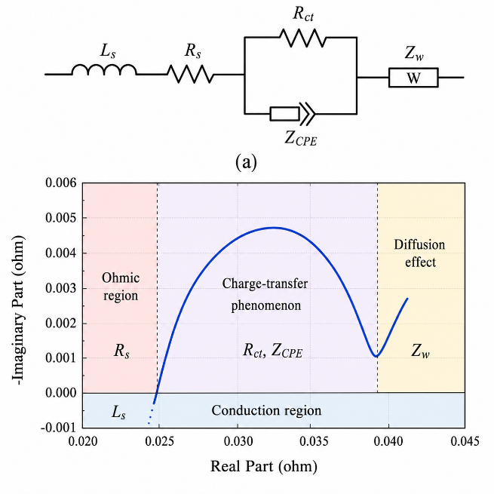
Figure 1-1 Nyquist impedance plot of Samsung INR18650
In terms of engineering implementation, the research focus has shifted to online and built-in systems in recent years. Cicioni et al. proposed an embedded battery impedance measurement system that put small current perturbations when battery charge or device run power, and get voltage and current at same time to estimate impedance at different frequencies; Then mix equal circuit and genetic algorithm to see how parameter variations with SoC [4]. Kuipers et al. then put forward an online EIS and estimation method for battery management systems, which keep measure impedance by iterative processing current and voltage and change equal circuit parts by itself; The check show that impedance and guess have high accuracy, but guess right go down when big DC current on top [6]. Blomeke et al. talk about the opportunities and limitations of online EIS measure using same resistors at system level, point out that plan can use hardware again, but its signal-to-noise is held by things like sampling, averaging, FFT, analog resolution and filter bandwidth [5]. These works show that online EIS can work but still constrained by implementation complexity and sensitive to measurement conditions [4][5][6].
To shorten measurement time and get high-frequency domain info fast, multi-frequency excitation and fast spectral analysis methods become important research direction. Regnacq et al. make a fast many-frequency EIS thing with Goertzel filters, try to make many-frequency impedance get better [10]. Lourenco et al. do a stand-alone embedded multi-sine measure system for battery age check, help auto charge-discharge and measure loops and use less memory with multi-sine push, same sample, and sample-updated Goertzel filter [3]. Also, De Angelis et al. show a uncertainty way for real wide-band battery EIS systems, say low-complexity systems with voltage-controlled current sources and wide-band multi-sine push can do measure fast and get same results as shop gear in 0.05 Hz to 1 kHz range [11].
Overall, past EIS check studies show three clear tech ways. First, EIS move from lab tools in room to put-in and online work. Second, shake and signal-handle ways go from one-frequency look to many-frequency and fast picture get. Third, measure doubt, signal-to-noise number, and hardware re-use become big things that say if EIS can be real put into BMS systems. These ways give a direct theory and engineer base for this study, which want to do EIS excite put and impedance get inside a power converter-based put-in lithium battery measure system.

1.2.3 SoC/SoH Estimation Methods Development: From Model-Driven to Data-Driven
Besides doing impedance measure itself, the making of SoC and SoH estimation methods also show a move from model-driven methods to data-driven methods, and from single algorithm to hybrid or fusion algorithms. Xiong et al. say that, because battery systems have non-linearity, time change, and uncertainties, high-precision real-time SoC estimation has always been hard. So, the good parts, bad parts, and error sources of different estimation methods need to be systematically compared [9]. At old feature level, Hu et al. say the normal coulomb count way and open-circuit voltage way have problems like error that add up and slow answer, each one, which tell why researchers keep bring in frequency-domain features with more info or learning ways with stronger fit power [2]. Li et al. did a compare study on how OCV test things affect SoC guess and show that different OCV get ways and temp conditions can change the OCV-SoC link, so messing up guess rightness. Their work also says that an adaptive extended Kalman filter mixed with a right OCV test link can get better work inside their study frame [19].
In data way things, machine learning is big used for SoC guess. Hu and others made a smart SoC guesser with machine learning, where fuzzy groups made better by a gene method was used for train data split, and simple least squares with backpropagation were mixed for learning stuff. The test results show its rightness was better than old fuzzy model ways [15]. Eleftheriadis and others then say, when battery data small and complex battery behaviour, transfer learning can cut train cost and make guess better with help of already trained models. Their look at many recurrent neural networks and transfer learning ways show some move plans got a good mix of accuracy and compute time [12]. Later, Hu and others mix EIS stuff with SHAP, ASO, and LightGBM for SoC guess of lithium iron phosphate batteries. Their results show higher fit and lower wrong than the looked at LSTM and DNN models, showing that the mix of "frequency-domain features + feature selection/interpretability + ensemble learning" has big chance [2].
For robust estimation and health diagnosis, filter ways and deep learn ways keep change too. Liu et al. put out a adaptive H∞ filtering method, which does change fix of guess by making better the forget factor and noise covariance, and got good SoC guess accuracy and strong in their work [16]. One other work use the big H-infinity filter idea for SoC guess, mix the state step of big Kalman filter with the robust suppression of uncertainty by H-infinity filter, so make guess steady under complex operating conditions [20]. For SoH and life guess, Lee and Kim put out a online SoH guess way based on a unscented particle filter by take out good health signs during battery work and make their map link to SoH. Online track of nonlinear and non-Gaussian degradation processes was done, with the big guess wrong kept under 5% [18]. Zhang et al. use long short memory nets for battery health guess and say this kind of way can learn long time links in capacity degradation, so make better the guess work of left life or health state [17]. These works show now battery state check has grow from guess now state to track down and guess future health change [16][17][18][20].
So, existing studies have formed three relatively clear technical directions. First one is state show frame from auto test and equivalent circuit model [13][14]. Second is EIS get features for SoC, SoH, and internal temperature estimation, plus its online and inside use [1][3][4][5][6][7][10][11]. Third is state guess and health diagnosis from machine learn, move learn, and strong filter [2][12][15][16][17][18][19][20]. But, some same problems stay. Online EIS systems still need better in hardware re-use, signal-to-noise ratio, unsure control, and keep right under big DC bias [5][6][11]. Even data ways can get high right, their work still touch by data quality, training strategy, and generalisation ability [2][12]. Guess ways from OCV or same models still affected by test conditions, temp change, and model wrong [19][20]. So, do good impedance measure under inside hardware limits and mix impedance features with strong state estimation methods still important direction for further research in this area [1][4][6][11].

1.3 Problem Definition and Objectives
Even if existing SoC estimation methods have a kind of mature framework, normal ways still have clear limitations. For example, the coulometric way is prone to error over time, the open-circuit voltage method is slow to answer, and the OCV-SOC link itself get changed by test stuff, which then reduce estimation accuracy [2][9][19]. So, estimation methods that only use old time or still features are difficult to balance real-time performance, accuracy and robustness at same time.
Compare to those the above methods, electrochemical impedance spectroscopy can show the inside battery electric behavior by using response info at different frequencies, so it's big used in SoC, SoH and internal temperature studies [1]. Lately, embedded impedance measurement systems, online EIS methods, fast multi-frequency EIS and wideband measurement uncertainty check have come out one after another, showing EIS has slowly go from offline analytical tools to online and engineering applications [3][4][5][6][10][11]. But, based on existing studies, the related work still show some common issues: First, need a balance between hardware resources, signal-to-noise ratio and processing complexity in online or embedded measurements; Second, while wideband and multi-frequency measures can make things faster, measurement uncertainty and how to do it cannot be ignored; Third, under real operating conditions, how stable the impedance get and parameter estimation is still a big thing that stops more use [5][6][11]. So, how to get good impedance info under real operating conditions and use it for subsequent state estimation is the core issue addressed in this study.
For fix battery control systems, this thing not just a signal measure problem, but also a mix problem with power interface, control strategy, sampling method and frequency-domain analysis. In real charging conditions, battery current have both DC charging component and small AC shake part for EIS check. If AC shake put straight on current reference and only track by conventional PI current loop, the injection accuracy may be okay in low-frequency range, but the amplitude attenuation and phase lag get more big as excitation frequency go up. This mean the make of an EIS check system must think not only if impedance can be calculated, but also if the shake flow can be right make and keep over the needed sound band. Therefore, the control strategy of the power converter becomes a key part of the measurement system rather than a separate charging-control issue.
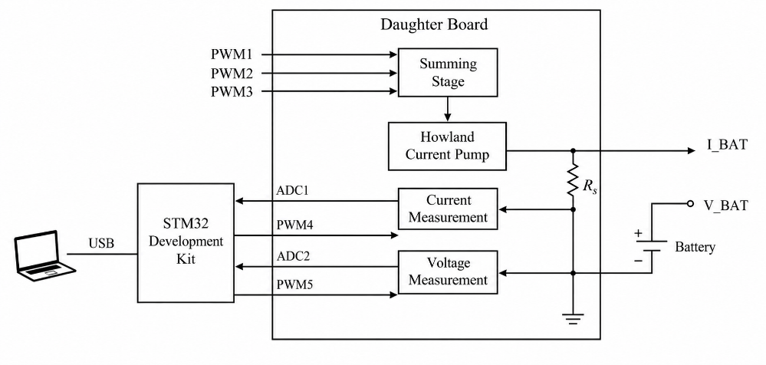
Figure 1-2 Block diagram of an embedded EIS measurement system
At same time, data ways and strong clean methods have been used to make battery state guess more right. Machine learn ways based on inside Electrochemical Impedance Spectroscopy (EIS) stuff, transfer learn tricks, and H∞-like clean ways all show big make guess better [2][12][15][16]. Work on online State of Health (SoH) guess and health guess more show battery state watch slowly change from just now state guess to whole life track and health trend guess [17][18]. But, these ways still need a steady and can do again feature get process. If impedance feature data get big hurt by things like wrong put in, sample noise, frequency fix off, or work condition change, then later State of Charge (SoC) or SoH guess models will lose their trust. So, before build hard data guess models, first big thing is make a full frame for inside impedance measure and model.
In summary, the primary objectives of this study can be outlined as follows:
(1) To establish a comprehensive system-level design scheme for an embedded lithium-ion battery EIS (Electrochemical Impedance Spectroscopy) testing system. This system integrates impedance testing capabilities directly into the constant-current charging process, thereby enabling the DC-DC converter, sampling circuitry, and digital controller to concurrently execute the dual tasks of charge control and AC excitation injection. This lays a solid system-level foundation for realizing low-cost, online impedance testing within the context of Battery Management System (BMS) applications.
(2) To conduct an in-depth investigation into the power topology and current control strategies for the miniaturized EIS system. The study confirms that a Buck-converter-based charging module can serve as the core power stage of the system; furthermore, it clearly elucidates the intrinsic correlations among duty cycle control, battery current response, and the resulting impedance measurements. Additionally, the study analyzes the limitations inherent in PI-controller-based hybrid current-following strategies within the high-frequency range, thereby substantiating the necessity of introducing a decoupled AC/DC control strategy.
(3) To construct and validate a MATLAB/Simulink simulation model specifically designed for the aforementioned EIS measurement system. This model encompasses core components such as the battery circuit, power conversion module, control unit, AC excitation generation module, and impedance calculation module. By conducting simulation experiments, key performance indicators—including excitation frequency characteristics, current tracking accuracy, impedance magnitude error, and impedance phase error—can be preliminarily evaluated and analyzed prior to the physical construction of the hardware prototype.
(4) It enables the effective acquisition and visual representation of battery impedance characteristics within a preset test frequency range of 5 Hz to 2 kHz. By applying a controlled sinusoidal current excitation and extracting the corresponding voltage and current responses at the same frequency, the complex impedance, impedance magnitude, and impedance phase angle can be determined. The sim results are compare with theoretical reference values to see if the measure way is good.
(5) To give a method base for later SoC estimation from impedance stuff. Though big part of this paper is the model, control and sim check of the built EIS measure part, the real impedance size, impedance angle and frequency-related features can help make impedance-SoC map models. This also get ready for later go to data-driven guess, strong filter, SoH diagnosis and battery-pack consistency evaluation.
In short, big problem of this work is how to get steady and right impedance feature extraction under built-in charge conditions. Around this problem, the paper look at the all-in-one design of converter-based push of excitement, split current control, simulation verification and impedance math. The expected contribution is to make a workable model and control frame for inside lithium-ion battery EIS measure, so help later online SoC guess and battery state check study.

Chapter 2 Embedded Lithium Battery EIS Measurement System Architecture

2.1 DC-DC Buck Converter

2.1.1 Buck Converter
In a embedded lithium battery EIS measurement (EIS) measure system, the DC-DC converter do both the energy conversion task for battery charge and also act as the power interface for AC push and response measurement. So, pick of the power stage topology will directly affect the system's control complexity, the output current ripple, and the right of subsequent impedance extraction. Studies show battery impedance info can be used for jobs like charge state (SOC), health state (SOH), and parameter identification [1][2][6][7], while inside measure systems often like to use old power converters, sample parts, and digital control resources to cut extra hardware cost and make online measure better [3][4].
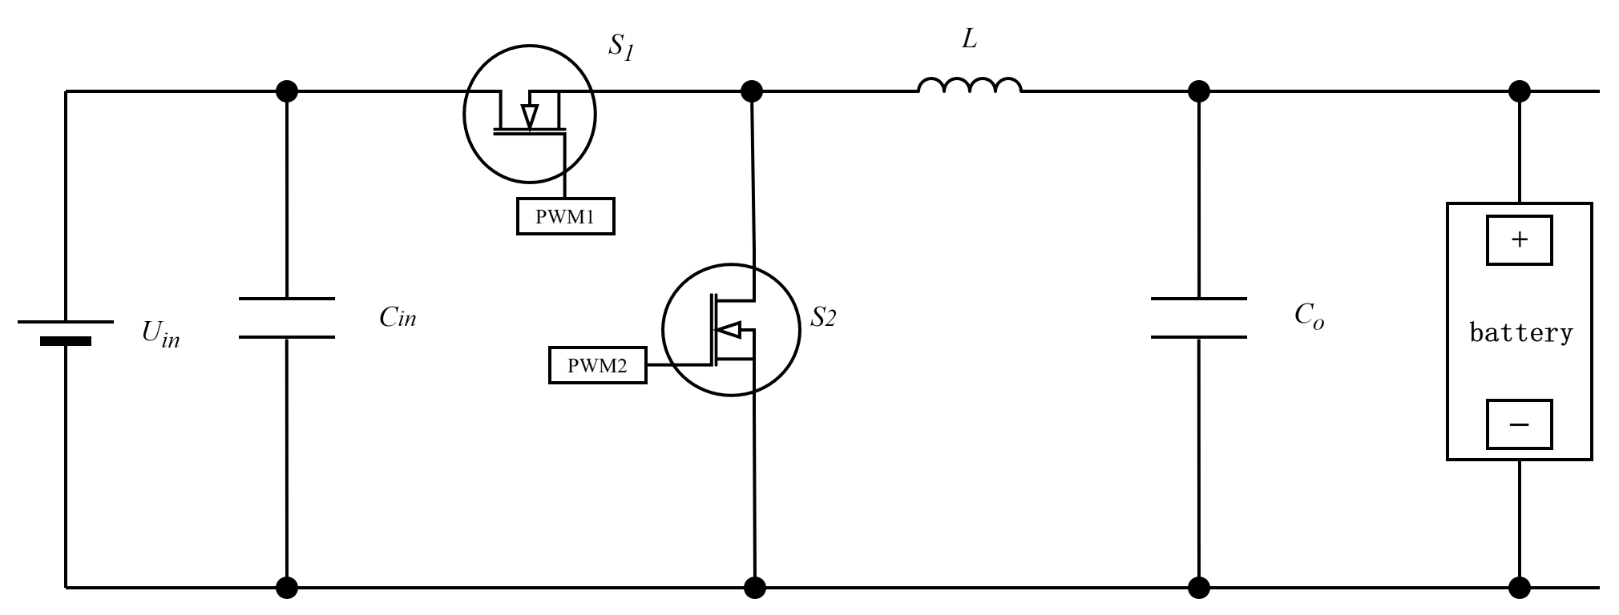
Figure 2-1 Operating current path of the Buck converter over one switching cycle
For a one-cell lithium battery system when charging, the Buck converter can step down the voltage from a high DC bus voltage to a low battery end voltage, so it good as basic power topology for constant current charge times. A Buck converter usually have input power 𝑈𝑖𝑛, a switching device 𝑆, a freewheel diode 𝐷 (or sync switch), a store energy inductor 𝐿, an output cap 𝐶, and a battery load. The main idea is change the average voltage on the inductor by control the on-off time ratio of the switching device in a fixed switch cycle, so get control of output voltage and output current.
For this work, the significance of the Buck converter is not just for conventional charging. More big, it makes a way to control for making a mixed current that has a DC charging component and a small AC shake part. In the constant-current charge step, the controller puts a small sinusoidal perturbation on the DC current target. After PWM fix, this mixed target works on the Buck power part, so the converter sends a current part at the target EIS frequency into the battery. By check the battery end voltage answer at the same speed, the battery's complex impedance can then be found. So, in this project, the Buck converter is changed from a old "energy change unit" to a "measurement execution unit" for inside EIS.

2.1.2 Closed-Loop Control of the Buck Interface Converter
In the inside battery EIS check system, the Buck converter do two joined jobs: it give step-down charge power from DC bus to battery side, and it make the small-signal AC shake needed for impedance check. So, the dynamic characteristics of Buck power part directly set how well the battery current loop can be controlled and the good frequency range for getting impedance. When the shake frequency goes up, the system get stuck by converter power-stage bandwidth, the sample part, and the accuracy of impedance get algorithm. So, it need to make a small-signal model of Buck converter with a lithium battery load, and then look at if closed-loop current control work for EIS shake.
For the subsequent derivation, the Buck converter is think to run in continuous conduction mode (CCM). The lithium battery is represented by a first-order Thevenin equivalent model, including an open-circuit voltage $U_{oc}$, an ohmic resistance $R_{o}$, a polarization resistance $R_{p}$, and a polarization capacitance $C_{p}$. Compare to a perfect resistor load, the lithium battery show frequency-based complex impedance under AC shake. So, when get the duty-cycle-to-battery-current transfer function, the battery model must put in the state equations. To keep the main power stage dynamic effect, the inductor series resistance $r_{L}$ is put in the derivation. The ESR of the output capacitor can be considered as an additional damping factor in simulation, without changing the main conclusion of this section.
1) The equation of state when S1 is on
When the switch tube S1 is on, the input power supply directly supplies energy to the inductor, output capacitor and battery branch. At this point, the system equation of state can be written as
$$\begin{aligned}\left\{\begin{aligned}L\frac{di_{L}}{dt}=U_{in}-r_{L}i_{L}-u_{o} \\ C\frac{du_{o}}{dt}=i_{L}-i_{b} \\ u_{o}=U_{oc}+u_{p}+R_{o}i_{b} \\ \frac{C_{p}\left(du_{p}\right)}{dt}=i_{b}-\frac{u_{p}}{R_{p}}\end{aligned}\right.\#\left(2-1\right)\end{aligned}$$
2) The state equation when S1 is turned off
When the switching tube S1 is off, the inductance continues to release energy to the output side through the freewheeling branch, and the system state equation is written as
$$\begin{aligned}\left\{\begin{aligned}L\frac{di_{L}}{dt}=-r_{L}i_{L}-u_{o} \\ C\frac{du_{o}}{dt}=i_{L}-i_{b} \\ u_{o}=U_{oc}+u_{p}+R_{o}i_{b} \\ \frac{C_{p}\left(du_{p}\right)}{dt}=i_{b}-\frac{u_{p}}{R_{p}}\end{aligned}\right.\#\left(2-2\right)\end{aligned}$$
3) Periodic averaging model
Let the duty cycle of the Buck converter be d, then the weighted average of the on and off states within one switching cycle yields the large-signal average model of the system as
$$\begin{aligned}\left\{\begin{aligned}L\frac{di_{L}}{dt}=dU_{in}-r_{L}i_{L}-u_{o} \\ C\frac{du_{o}}{dt}=i_{L}-i_{b} \\ u_{o}=U_{oc}+u_{p}+R_{o}i_{b} \\ \frac{C_{p}\left(du_{p}\right)}{dt}=i_{b}-\frac{u_{p}}{R_{p}}\end{aligned}\right.\#\left(2-3\right)\end{aligned}$$
4) Steady-state operating point equation
Let the system operate near the steady-state operating point, and the steady-state relationship can be obtained from Equation (2-3)
$$\begin{aligned}\left\{\begin{aligned}0=DU_{in}-r_{L}I_{L}-U_{O} \\ 0=I_{L}-I_{B} \\ U_{O}=U_{oc}+U_{P}+R_{o}I_{B} \\ 0=I_{B}-\frac{U_{P}}{R_{p}}\end{aligned}\right.\#\left(2-4\right)\end{aligned}$$
From the fourth equation of Equation (2-4), it is obtained
$$U_{P}=R_{p}I_{B}$$
After substituting the third formula, the open-circuit voltage of the first-order lithium battery model is
$$\begin{aligned}U_{O}=U_{oc}+\left(R_{o}+R_{p}\right)I_{B}\#\left(2-5\right)\end{aligned}$$
5) Introduce small perturbations
To analyze the AC perturbation tracking ability of the system, small-signal variations are introduced around the steady-state operating point
$$\begin{aligned}\left\{\begin{aligned}i_{L}=I_{L}+Δi_{L} \\ u_{o}=U_{O}+Δu_{o} \\ i_{b}=I_{B}+Δi_{b} \\ u_{p}=U_{P}+Δu_{p} \\ d=D+Δd\end{aligned}\right.\#\left(2-6\right)\end{aligned}$$
Substituting Equation (2-6) into equation (2-4) and subtracting the steady-state term gives a linearized small-signal model
$$\begin{aligned}\left\{\begin{aligned}\left(Ls+r_{L}\right)Δi_{L\left(s\right)}=U_{in}Δd\left(s\right)-Δu_{o\left(s\right)} \\ CsΔu_{o\left(s\right)}=Δi_{L\left(s\right)}-Δi_{b\left(s\right)} \\ Δu_{o\left(s\right)}=Δu_{p\left(s\right)}+R_{o}Δi_{b\left(s\right)} \\ C_{p}sΔu_{p\left(s\right)}=Δi_{b\left(s\right)}-\frac{Δu_{p\left(s\right)}}{R_{p}}\end{aligned}\right.\#\left(2-7\right)\end{aligned}$$
6) Laplace transform
Perform the Laplace transform on equation (2-7), and we get
$$\begin{aligned}\left\{\begin{aligned}\left(Ls+r_{L}\right)Δi_{L\left(s\right)}=U_{in}Δd\left(s\right)-Δu_{o\left(s\right)} \\ CsΔu_{o\left(s\right)}=Δi_{L\left(s\right)}-Δi_{b\left(s\right)} \\ Δu_{o\left(s\right)}=Δu_{p\left(s\right)}+R_{o}Δi_{b\left(s\right)} \\ C_{p}sΔu_{p\left(s\right)}=Δi_{b\left(s\right)}-\frac{Δu_{p\left(s\right)}}{R_{p}}\end{aligned}\right.\#\left(2-8\right)\end{aligned}$$
From the fourth equation in Equation (2-8), the relationship between the polarization voltage and the battery current can be obtained:
$$\begin{aligned}\left\{\begin{aligned}Δu_{p\left(s\right)}=\frac{R_{p}}{1+sR_{p}C_{p}}·Δi_{b\left(s\right)} \\ Δu_{o\left(s\right)}=\left(R_{o}+\frac{R_{p}}{1+sR_{p}C_{p}}\right)Δi_{b\left(s\right)}\end{aligned}\right.\#\left(2-9\right)\end{aligned}$$
Thus, the small signal impedance of the lithium battery can be defined as
$$\begin{aligned}Z_{bat}\left(s\right)=\frac{Δu_{o\left(s\right)}}{Δi_{b\left(s\right)}}=R_{o}+\frac{R_{p}}{1+sR_{p}C_{p}}\# \left(2-10\right)\end{aligned}$$
7) Duty cycle - Battery current transfer function
From Equation (2-8) and Equation (2-10)
$$\begin{aligned}Δi_{L\left(s\right)}=\left(1+CsZ_{bat}\left(s\right)\right)Δi_{b\left(s\right)}\# \left(2-11\right)\end{aligned}$$
Substituting it into the first equation (2-8), we get
$$\begin{aligned}\left\{\begin{aligned}\left[\left(Ls+r_{L}\right)\left(1+CsZ_{bat}\left(s\right)\right)+Z_{bat}\left(s\right)\right]Δi_{b\left(s\right)}=U_{in}Δd\left(s\right) \\ G_{id}\left(s\right)=\frac{Δi_{b\left(s\right)}}{Δd\left(s\right)}=\frac{U_{in}}{\left(Ls+r_{L}\right)\left(1+CsZ_{bat}\left(s\right)\right)+Z_{bat}\left(s\right)}\end{aligned}\right.\#\left(2-12\right)\end{aligned}$$
Equation (2-11) is the duty cycle - battery current transfer function of the Buck converter under a first-order Thevenin battery load. Substituting equation (2-10) further into the above equation yields an explicit polynomial expression:
$$\begin{aligned}Z_{bat\left(s\right)}=\frac{\left(R_{o}+R_{p}\right)+R_{o}R_{p}C_{p}s}{1+R_{p}C_{p}s}\#\left(2-13a\right)\end{aligned}$$
$$\begin{aligned}G_{id\left(s\right)}=\frac{U_{in}\left(1+R_{p}C_{p}s\right)}{D\left(s\right)}\#\left(2-13b\right)\end{aligned}$$
$$D\left(s\right)=LC C_{p}R_{o}R_{p}s^{3}$$
$$+\left(C C_{p}R_{o}R_{p}r_{L}+CL\left(R_{o}+R_{p}\right)+C_{p}L R_{p}\right)s^{2}$$
$$+\left(L+C r_{L\left(R_{o}+R_{p}\right)}+C_{p}R_{p\left(r_{L}+R_{o}\right)}\right)s$$
$$\begin{aligned} +\left(r_{L}+R_{o}+R_{p}\right)\#\left(2-13c\right)\end{aligned}$$
Equation (2-13) say the battery current response is set by Buck power-stage characteristics and battery model together. This is not like a simple resistor Buck model, cause the battery's polarization branch add more frequency-based magnitude and phase characteristics.
8) Low-frequency closed-loop current control model
If the current controller is in PI form, then there is
$$\begin{aligned}\left\{\begin{aligned}G_{c}\left(s\right)=K_{p}+\frac{K_{i}}{s} \\ T_{i}\left(s\right)=\frac{K_{pwm}G_{c}\left(s\right)G_{id}\left(s\right)}{1+K_{pwm}G_{c}\left(s\right)G_{id}\left(s\right)H_{i}\left(s\right)}\end{aligned}\right.\#\left(2-14\right)\end{aligned}$$
Here, $K_{pwm}$ is the equivalent gain of the PWM link, $H_{i\left(s\right)}$ is the transfer function of the current sampling link, $T_{i\left(s\right)}$ is the current closed-loop transfer function.
In the low band, if the current loop bandwidth is high enough, the amplitude of $T_{i\left(s\right)}$ is close to a constant, at which point the AC perturbation current can be directly superimposed onto the DC reference current, that is
$$\begin{aligned}i_{ref}\left(t\right)=I_{ref}+i_{ac}\sin\left(ωt\right)\#\left(2-15\right)\end{aligned}$$
This means that, at low excitation frequencies, the PI controller can simultaneously maintain the DC charging operating point and track the small AC excitation current. Therefore, the “DC charging current + AC perturbation current” reference can be used directly as the input of the current loop.
9) High-frequency DC-AC decoupling duty-cycle control
As the excitation frequency increases, the magnitude of $G_{i}d(jω)$gradually decreases and the phase lag becomes more obvious. This thing show duty-cycle perturbation has reduced control authority on battery current in high-frequency band. Same time, output capacitor part do more shunting work on high-frequency AC parts. So, high-frequency current made by Buck power stage not all go into battery branch, but some get taken by output capacitor. If still use low-frequency way in Equation (2-15), that mean use mixed AC/DC current reference and trust PI loop to follow it, the put-in current will get amplitude attenuation and phase lag, this make EIS impedance measurement accuracy decreases.
Therefore, for high-frequency EIS measurement, a more suitable control form is
$$\begin{aligned}d\left(t\right)= d_{dc\left(t\right)}+ d_{ac\left(t\right)}\#\left(2-16a\right)\end{aligned}$$
$$\begin{aligned}d_{ac\left(jω\right)}=\frac{I_{ac}*}{K_{pwm}G_{id\left(jω\right)}}\#\left(2-16b\right)\end{aligned}$$
$$\begin{aligned}φ_{d\left(ω\right)}= -∠G_{id\left(jω\right)}\#\left(2-16c\right)\end{aligned}$$
The good thing of this DC-AC decoupled strategy is the PI controller no need to chase high-frequency sinusoidal current. Instead, the PI loop main job is for the slow DC charging component, while the AC push is put in through a feedforward duty-cycle path. This skip the extra phase wrong that the PI integration term make at high-freq and make better the amplitude-phase consistency of the injected AC current. So, the Buck converter can more good do both steady current charge and wideband EIS push needs.
10) Control policy and Switching frequency
The EIS measure system for inside lithium battery does not use the same control strategy in all frequency band. It change between PI control strategy and AC/DC decouple control strategy as AC excite frequency go different. This happen because PI controller track reference current good in low frequency domain. But when frequency get high, its close-loop gain and phase characteristics gradually deteriorate. This make output AC current amplitude deviates from the reference value and hurt impedance measure accuracy.
According to the system model established earlier, the closed-loop transfer function of the embedded lithium battery EIS measurement system based on PI control can be written as:
$$\begin{aligned}T\left(s\right)=\frac{G_{PI\left(s\right)}G_{P\left(s\right)}}{\left(1 + G_{PI\left(s\right)}G_{P\left(s\right)}\right)}\#\left(2-17\right)\end{aligned}$$
Here, $G_{PI\left(s\right)}$ is the PI controller transfer function, and $G_{P\left(s\right)}$ is the transfer function from the duty cycle of the bidirectional Buck/Boost converter to the output current. The PI controller can be expressed as:
$$\begin{aligned}G_{PI\left(s\right)}= K_{p}+\frac{K_{i}}{s}\#\left(2-18\right)\end{aligned}$$
When $T\left(jω\right)≈ 1$, that is, the closed-loop amplitude gain is close to 0 dB, it indicates that the system output current can track the reference AC excitation current well; When $\left|T\left(jω\right)\right|$ deviates significantly from 1, it indicates that the AC excitation signal has been amplitude-amplified or attenuated during the injection process. If PI control is still used at this time, it will cause the actual injection current to be inconsistent with the set value, thereby destroying the small signal condition and amplitude-phase accuracy required for EIS measurement.
Based on main circuit parameters and PI controller parameters made before, a look at Equation (3-20) in frequency domain give the amplitude-frequency response curve of the closed-loop transfer function. The look results show that in low frequency part, the closed-loop gain of the system stay near 0 dB, this mean the PI controller can follow the mixed reference current good; But as the frequency continued to rise, the closed-loop gain began to deviate significantly from 0 dB, at which point the AC component of the output current was no longer equal to the set AC excitation current.
Figure 2-2 Amplitude-frequency response of closed-loop transfer function for embedded lithium battery EIS measurement system based on PI control
From the amplitude-frequency curve, the system's close-loop gain start big change around about 1.020 kHz. Therefore, in this paper, the control strategy switching frequency is designed as:
$$\begin{aligned}f_{tr}= 1.020 kHz\#\left(2-19\right)\end{aligned}$$
When $f$ less than $f_{tr}$, the system adopts the PI control strategy. At this time, the PI controller works well for low-frequency EIS measure cause it make stable DC charge current and right track the low-frequency AC excite current put on the reference thing.
When $f$ big or same as $f_{tr}$, the system change to a AC-DC separate control way. At this time, the PI controller only do job for regulating the DC component of the output current, but the high-freq AC part go straight into the power stage by duty cycle fix, so it skip the PI controller's bandwidth limitation and the high-frequency attenuation problem of the power stage. With this split control, the system keep the good of PI control with no error tracking for DC, while make better the size and phase accuracy of the high-freq AC push current.
From an engineering making side, for stop plan shake from AC excite frequency go back and forth near switch point, a bit of hysteresis band can also be set near switch limit in real making. For example, set the upper limit of PI control to 1.100 kHz and the lower limit of AC/DC decoupling control to 1.150 kHz. This can effectively reduce repetitive switching near the frequency critical point and improve the stability of system operation. Given that this paper is mainly based on simulation verification, $f_{tr}= 1.020 kHz$ is still used as the control strategy switching frequency in subsequent simulations.
So, by look at the amplitude-frequency response of the closed-loop transfer function, the control strategy switching frequency is set to about 1.020 kHz. This number is a key design result for linking low-frequency PI control with high-frequency AC/DC decouple control and an important first step for doing wideband EIS measure.

2.2 Architecture of the Embedded Lithium Battery EIS Measurement System
Normal electrochemical impedance spectroscopy tests often use dedicated instruments, like electrochemical workstations. Although these instruments can provide accurate impedance spectra, they are not always suitable for online battery management applications because they are relatively bulky, costly, and normally separated from the charging circuit. In many cases, the battery also has to be tested under a controlled condition rather than during its normal operation. Therefore, if EIS is to be used in an embedded battery management system, the measurement function should be integrated with the existing power conversion and sensing circuits as much as possible.
Based on this consideration, the system studied in this project embeds the EIS measurement function into the lithium battery charging circuit. The big point is use the power converter not just for the charging interface, but also as the mover for small-signal current excitation. At same time, the voltage and current sensing circuits and the digital controller are reused for response acquisition and impedance math. This way, the system can cut the need for extra push hardware and make online impedance check more real for BMS-oriented applications [4][5][6].
For the overall architecture, the inside lithium battery EIS measure system big part have a regulated DC input supply, a two-way Buck/Boost power converter, a controller, a MOSFET driver circuit, a voltage and current sample circuit, a auxiliary power supply, and the lithium battery under test. In these, the two-way Buck/Boost changer do the energy move between the DC bus and the battery end. It also is the direct do step for put in the AC shake current. The controller make the current reference, handle the shake frequency, do closed-loop fix, and work with the measured voltage and current signals for impedance math. The MOSFET driver circuit turn the PWM sign from the controller into good gate-drive signs for the power switches. The sample circuit measure the battery end voltage and current, with their AC parts, and give the base data for later frequency-domain analysis. The auxiliary power supply provides stable power for the controller, driver, and signal-conditioning circuits, so that the charging and measurement functions can operate at the same time.
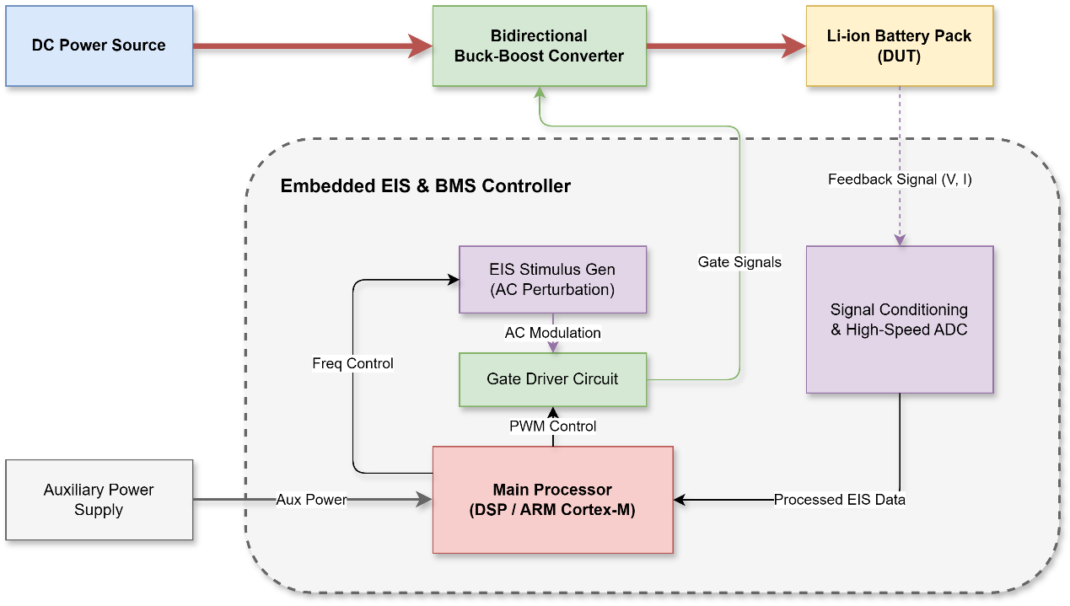
Figure 2-3 Architecture of embedded lithium battery EIS measurement System based on bidirectional Buck/Boost converter
Considering the lithium battery charging process, it can generally be divided into three stages: pre-charging, constant current charging, and constant voltage charging. So this study pick do EIS measure in the constant current charging part. This is because the operating point in this stage is relatively clear, the control objective is simple, and the battery current can be more conveniently regulated by the converter. At this stage, the system output current is composed of a DC charging component and a small AC excitation component, and the reference current can be expressed as:
$$\begin{aligned}i_{mix\left(t\right)}=I_{dc}+I_{ac}\sin\left(2πft\right)\#\left(2-20\right)\end{aligned}$$
In this expression, I_dc represents the constant charging current, I_ac represents the amplitude of the AC excitation current, and f represents the current measurement frequency. Since the AC excitation amplitude is much smaller than the DC charging current, the battery can still remain in a normal charging state under proper parameter design. At same time, the small AC current make a voltage response is generated at battery end. This give base for impedance math while meet small-signal need of EIS test.
In terms of signal flow. First, the DC power give energy to the bidirectional Buck/Boost converter. Then that converter fix the current go into the lithium battery. The controller send PWM signals using the current reference and the picked control way. After gate driving, the MOSFETs in the converter work at the set switch frequency. On the measure side, the battery end voltage and current are felt, fixed, and turned into digital signals. Then the processor get the AC amplitude and phase information at the excite frequency and work out the complex impedance. So the system setup make a closed path of "excitation generation - power-stage injection - battery response - signal acquisition - impedance calculation".
Compared to a offline EIS test setup, big good thing of this build is hardware reuse. The power converter do both energy change job and perturbation injection function, while control and sample parts are same used by charge control and impedance check. This cut more hardware need and fit better with small size, low cost, and little compute stuff of built-in BMS places. But, this build also bring some real limits. The measured impedance can get hit by switch noise, sample noise, limited ADC resolution, power-stage bandwidth, and the mix of DC charge control and AC shake put-in. These things show that just the system build is not enough; it must go with a good control way and signal-handle method to ensure reliable impedance extraction. The full control ways are talked in next part.

2.3 Control Strategy for the Embedded Lithium Battery EIS Measurement System
In the embedded lithium battery EIS measurement system, the control strategy is not only used to regulate the charging current of the bidirectional DC-DC converter, but also determines whether the small AC excitation current can be accurately injected into the battery branch. Therefore, the controller has two coupled tasks. The first task is to maintain a stable DC charging operating point during the constant-current charging stage. The second task is to make the AC excitation component follow the required amplitude and phase as closely as possible, so that the voltage and current responses used for impedance calculation are reliable.
For EIS measurement, the control objective is slightly different from that of a conventional charger. In a normal charging system, the main concern is the average charging current and the terminal voltage limit. In this work, but, the small AC part is also big important because the impedance come from the link between same-frequency voltage response and current excitation. If the injected AC current get made small or phase moved by the control loop, the got impedance will have more control-induced error. So, the control design need think about both charge steadiness and freq-domain measure accuracy.
2.3.1 Low-Frequency Reference Current Injection PI Control Strategy
Proportional Integral (PI) control is widely used in current closed-loop control of DC-DC converters because of its simple structure, clear physical meaning, low implementation cost, and ability to reduce steady-state current error. For the bidirectional Buck/Boost converter in this study, when it operates in Buck charging mode, the PI controller adjusts the duty cycle according to the error between the reference current and the measured output current. In this way, the converter output current can track the target current during the constant-current charging stage.

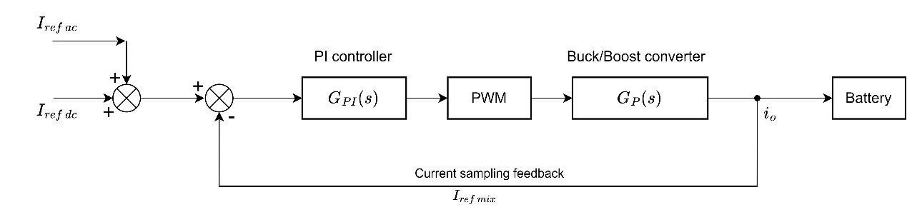
Figure 2-4 Block diagram of PI-controlled embedded lithium battery EIS measurement system
To embed the EIS measurement function into the charging process, the AC excitation current is superimposed on the DC charging reference quantity to form a mixed reference current, and this mixed signal is used as the input of the PI controller. In this way, the output current of the converter should theoretically contain the DC charging component and the AC shake part of same freq. For low-frequency disturbances, PI closed loops usual keep good tracking capability, so the system can hold steady current charge and do small AC signal put in, thus give a base for get impedance. From this idea, the PI control strategy can be see as the most direct and implementable control strategy for put-in EIS systems in the low-freq range.
$$\begin{aligned}I_{ref},mix\left(t\right)=I_{ref},dc+I_{ac}\sin\left(ωt\right)\#\left(2-20\right)\end{aligned}$$
$$\begin{aligned}T\left(s\right)=\frac{I_{o\left(s\right)}}{I_{ref}},mix\left(s\right)=\frac{G_{PI\left(s\right)}G_{P\left(s\right)}}{1+G_{PI\left(s\right)}G_{P\left(s\right)} }\#\left(2-21\right)\end{aligned}$$
$$\begin{aligned}G_{PI\left(s\right)}=K_{p}+\frac{K_{i}}{s}\#\left(2-22\right)\end{aligned}$$
$$\begin{aligned}\left|G_{PI\left(jω\right)}\right|=sqrt\left(K_{p}^{2}+{\left(\frac{K_{i}}{ω}\right)}^{2}\right)\#\left(2-23\right)\end{aligned}$$
According to Equation (2-20), the closed-loop tracking capability of an embedded lithium battery EIS measurement system based on PI control is determined jointly by the controller transfer function $G_{P}I\left(s\right)$ and the power stage transfer function $G_{P}\left(s\right)$. When the shake speed is slow, the integral term can give more low-frequency gain, making the output current get closer to the mix reference current; But when speed goes up, the integral term's work gets less strong, the PI controller's good gain goes down, and the power part itself has limit on how fast it can work, so the AC put-in signal shows amplitude attenuation and phase lag. The PI control way is more good for mix current close-loop control in low-speed area, but not for exact measures of wideband, special high-speed EIS alone.
2.3.2 High-Frequency Duty Cycle Injection AC/DC Decoupling Control Strategy
Aiming at the bandwidth limitation problem of PI control strategy in high-frequency measurement, this paper further studies the AC/DC decoupling control strategy. The core idea of this strategy is that instead of requiring a single PI loop to perform both "DC charging control" and "high-frequency AC excitation tracking" simultaneously, the DC and AC components in the output current are processed separately. The DC component is still handled by the PI controller to ensure constant current charging accuracy; The AC component bypasses the high-frequency bandwidth constraint of the PI and acts directly on the power stage through an independent duty cycle injection channel, thereby enhancing the controllability of the high-frequency excitation current. This approach can significantly improve the amplitude-phase consistency of the AC injection signal in high-frequency EIS measurements without disrupting the constant current charging target.

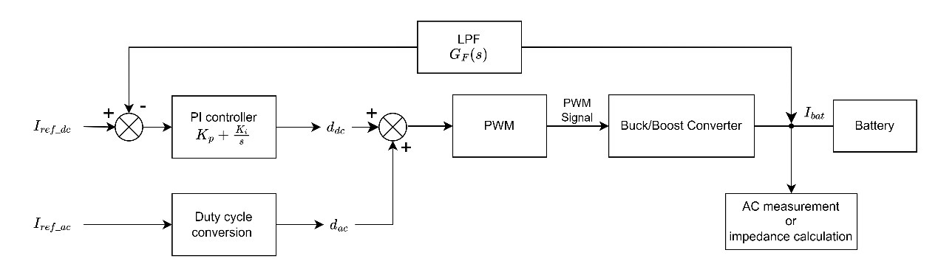
Figure 2-5 Block diagram of the AC/DC decoupling control strategy
In the specific implementation, a low-pass filter can be introduced into the output current feedback branch to extract the DC component from the output current and feed it back to the PI controller; At the same time, the target AC excitation signal is converted into an AC duty cycle perturbation through the duty cycle conversion module and superimposed on the DC duty cycle of the PI output. So, the final control signal the system send to the PWM modulator have two components: one bit keep the charge average current going, other bit make AC shake at the wanted frequency. This way, the PI controller mostly handle low-freq and DC stuff, while the AC add part mostly handle high-freq track stuff, get a "functional separation" in control job.
$$\begin{aligned}G_{F}\left(s\right)=\frac{ω_{c}}{s+ω_{c}}\#\left(2-24\right)\end{aligned}$$
$$\begin{aligned}d_{dc}\left(t\right)=PI\left[I_{ref,dc}-i_{F}\left(t\right)\right]\#\left(2-25\right)\end{aligned}$$
Here, $G_{F}\left(s\right)$ is the low-pass filter transfer function. For the solution $d_{a}c\left(t\right)$, the link of the target AC current and the duty cycle can be turned around with the power-stage small-signal model made before, so get the duty-cycle perturbation expression for high-frequency put-in. Because this thing split "high-frequency AC current track" from the PI loop, it can make less the close-loop bandwidth push on the high-frequency push.
Overall, the PI control way is good for the low-freq EIS measure part, with easy to do, stable close loop, and simple to mix with the steady current charge process; The AC-DC separate control way is more fit for the high-freq EIS measure part, as it can go past the bandwidth limitation of a single PI loop and make better the amp-phase track accuracy of the AC excite current. So, the put-in lithium battery EIS measure system should use the idea of multi-band control: PI control in the lower band, switch to AC/DC separate control in the higher band, and later find the control switch freq in the next part design.

Chapter 3 Achievement and Simulation

3.1 Design of Parameters for the Embedded Lithium Battery EIS Measurement System
The lithium battery EIS test system is made to do AC excitation injection, response acquisition and impedance calculation when the constant-current charge step happen. Therefore, the parameter design in this section is not only related to the basic operation of the bidirectional Buck/Boost converter, but also directly affects whether the small AC excitation current can be accurately generated and whether the voltage and current responses can be reliably extracted. In this work, the main design parameters have measurement frequency range, switch freq, sampling frequency, battery equivalent circuit parameters, converter part numbers and parasitic parameters.
In this chapter, parameter design is treated as the connecting part between the theoretical control analysis in Chapter 2 and the subsequent simulation results. These parameters are not merely selected to ensure the normal operation of the converter; they also need to guarantee that the EIS measurement process itself is observable. This is slightly different from the design of ordinary chargers. In conventional charging converters, as long as the average charging current is stable, a relatively small output ripple is usually acceptable. However, in this project, the effective signal itself is a small AC component. If the switching ripple, sampling interval, or converter dynamic response is not reasonably considered, the final impedance waveform may appear reasonable but still may contain hidden amplitude or phase errors.
Therefore, the design process in Chapter 3 follows a more practical sequence. Firstly, the measurement frequency range is determined as it dictates the switching frequency, sampling frequency, and the fundamental requirements for signal extraction. Subsequently, the battery equivalent circuit and converter parameters are set to ensure the simulation model has a stable operating point. Finally, the control module and impedance calculation module are connected in Simulink. Although this sequence is straightforward, it helps to avoid a common issue in simulation work: the model can run, but it is uncertain whether the measurement results have clear physical significance.
Unlike a conventional charging converter, this system's parameter selection need think both power change and impedance check. Low switch frequency can make current ripple bigger and cut high-freq control, but too high switch frequency can make switch loss and EM noise more. Same way, L and C values should be big enough to stop switch ripple, but they should not make system response too slow. So, parameters are picked by balance charge stable, excite track ability, signal observability and simulation feasibility.

3.1.1 Switching Frequency and Sampling Frequency
Switching frequency is one big thing in making Buck/Boost converters work. How much it is change the size of inductors and caps, system loss from switching, output current shake, and power to put in high-freq AC test signals. Most times, make switch times go up help cut down inductors and caps values, so system get smaller and react faster; But at the same time, the switching loss, drive loss and electromagnetic interference of the power device will also increase.
The target measurement frequency range of this system is 5 Hz - 2 kHz.
For the embedded EIS measurement function, the highest measurement frequency is 2 kHz, which means that the converter and sampling process must still provide sufficient time resolution at this frequency. If only the minimum sampling requirement is considered, the extracted waveform may still suffer from phase error, amplitude error and poor noise rejection. Since the impedance calculation depends on the same-frequency voltage and current components, the sampling frequency should provide enough data points in each excitation period rather than only meeting the basic theoretical limit.
Taking into account the maximum measurement frequency of EIS, the switching loss of power devices, the system volume and the complexity of control implementation comprehensively, this paper ultimately selects:
$$\begin{aligned}f_{s}= 200 kHz\#\left(3-1\right)\end{aligned}$$
That mean, 100 sampling points still can get in each AC cycle at a maximum measurement frequency of 2 kHz. The plan not just big go over the theoretical minimum requirement for sampling, but also keep enough room for get high-frequency impedance size and phase.
It should also be noted that the selected sampling frequency will affect the reliability of the phase information. For impedance math, size mistake is more easy to control than angle mistake. A real small time shift may not big change the look of wave shape, but after take out in frequency space, it can turn into a more clear angle change. This is more clear near the top of measure frequency band. At 2 kHz, one shake period is just 0.5 ms, so even a short time wait may take a not small part of the period.
In the make-believe test, the hit of this thing can be made smaller by pick one same time base for PWM making, current control, excite signal making, and impedance math. This setup not exactly same as a real inside controller, because real system may have small waits in ADC start, stop job run, and PWM update. But it give a fairly clean base case. If the perfect step model can't keep good phase right, later hardware work will be more hard. So the sample plan in this part is not just a number set; it is also a must-do prep to see if the put-in EIS way has enough time room.

3.1.2 Model Parameters
To achieve the design goals of this paper, the parameter settings for each part of the model are shown in Table 3-1. The design process and basis for each component parameter are as follows.
The open-circuit voltage is set to 3.6 V and the rated output voltage is set to 3.7 V, which corresponds to a typical single-cell lithium-ion battery operating region in the charging process. The DC charging current is selected as 975 mA, and the AC excitation current amplitude is set to to 50 mA. This make the small push current next to the DC charge current, so the system can keep the same-current charge state while still make a measurable AC voltage response for get impedance.
For the converter side, the input voltage is set to 12 V, this give enough voltage room for Buck-mode charge of a single lithium-ion cell. The input cap, input-side inductor, output-side inductor and output cap are pick to stop switching noise and make the battery-side current more smooth. In special, the output cap and the small output-side inductor are key for cutting high-frequency switching parts that could interfere with the measured AC response. At the same time, the DCR of the inductors and the ESR of the capacitor are included in the model, so that the simulation is closer to an actual circuit rather than an ideal lossless converter.
(1) Constant current charging current and small signal injection current
During the constant current charging phase, considering the capacity and safety requirements of the lithium battery, the DC charging current is initially set at 0.3C, that is:
$$\begin{aligned}I_{dc}= 0.3 × 3.25 A ≈ 0.975 A\# \#\left(3-2\right)\end{aligned}$$
To meet the linear conditions for EIS small-signal measurements, the amplitude of the AC excitation current should be significantly smaller than the DC charging current. Combining the signal-to-noise ratio and battery linear response requirements, this paper selects an AC excitation current amplitude of 50 mA, then we have:
$$\begin{aligned}\frac{I_{ac}}{I_{dc}}=\frac{50 mA}{975 mA} ≈ 5.13\%\#\left(3-3\right)\end{aligned}$$
This ratio ensures that the AC response voltage has a certain degree of measuability without causing significant disturbance to the original working state of the battery.
For the main circuit in the Buck operating state, let the input voltage be $U_{in}= 12 V$ and the output voltage be $U_{o}= 3.7 V$, then the steady-state duty cycle is:
$$\begin{aligned}D =\frac{U_{o}}{U_{in}}=\frac{3.7}{12} ≈ 0.308\#\left(3-4\right)\end{aligned}$$
(2) Design of inductance $L_{1}$ on the input side
The main function of inductor $L_{1}$ is to smooth the input-side current, limit the switching current ripple, and improve the controllability of the AC excitation current injection. In the design of a Buck converter, the inductor current ripple is usually given first, and then the inductor value is inversely calculated. If the current ripple is set too small, the required inductance will be too large, not only increasing the volume and cost, but also causing the inductance DC resistance to increase; If the current ripple is set too high, it will increase the output current peak and intensify the capacitance ripple, which is not conducive to high-precision impedance measurement.
Combining efficiency, volume and measurement accuracy requirements, this paper sets the inductor current ripple to 20% of the DC charging current, that is:
$$\begin{aligned}ΔI_{L1}= 0.2I_{dc}= 0.195 A\#\left(3-5\right)\end{aligned}$$
The inductance value of the Buck converter in continuous conduction mode can be calculated by the following formula:
$$\begin{aligned}L_{1}=\frac{U_{o\left(1 - D\right)}}{ΔI_{L1}f_{s} }\#\left(3-6\right)\end{aligned}$$
Substituting$U_{o}= 3.7V, D = 0.308, ΔI_{L1}= 0.195A, f_{s}= 200 kHz$ into equation (3-10), we get:
$$\begin{aligned}L_{1}≈ 65.6 μH\#\left(3-7\right)\end{aligned}$$
Think this system need not just DC charge current out, but also a small AC shake current put on top. To make current ripple more small and make high-frequency injection more stable, in real design we reserve a design margin for the inductance value, and finally:
$$\begin{aligned}L_{1}= 100 μH\#\left(3-8\right)\end{aligned}$$
This value is greater than the theoretical calculation, which is beneficial for improving the smoothness of the output current and reducing the impact of switching ripple on the measurement of AC disturbances.
(3) Design of the output capacitor C
The function of the output capacitor C is to suppress the output voltage ripple, improve the stability of the battery terminal voltage, and reduce the interference of the switching process on the measurement of the AC response voltage. Because the AC response voltage amplitude of the battery itself is small, if the output voltage ripple is too large, it will cause significant contamination of the impedance measurement results. Therefore, this system imposes stricter requirements on the output voltage ripple.
Let the output voltage ripple be 0.02% of the output voltage, then we have:
$$\begin{aligned}ΔU_{o}= 0.0002U_{o}= 0.74 mV\#\left(3-9\right)\end{aligned}$$
When the output capacitor ESR is small and the ripple is mainly caused by the charging and discharging of the capacitor, the output capacitor of the Buck converter can be approximately designed by the following formula:
$$\begin{aligned}C ≥\frac{ΔI_{L1}}{\left(8f_{sΔU_{o}}\right)}\#\left(3-10\right)\end{aligned}$$
Substituting $ΔI_{L1}= 0.195 A$, $f_{s}= 200 kHz, ΔU_{o}= 0.74 mV$ into equation, we get:
$$\begin{aligned}C ≥ 164.7 μF\#\left(3-11\right)\end{aligned}$$
To further reduce the output voltage ripple and improve the testability of the battery terminal response signal, this paper selects the standard value:
$$\begin{aligned}C = 220 μF\#\left(3-12\right)\end{aligned}$$
This parameter not only meets the ripple requirements, but also helps to reduce the voltage fluctuation of the main circuit under high-frequency excitation conditions.
(4) Design of the input capacitor $C_{in}$ and the small inductor L_2 on the output side
To reduce the impact of ripple on the input power supply side on the system, the input capacitor $C_{in}$ is connected in parallel at the input end. In combination with the system power level and the experimental implementation requirements, this paper takes:
$$\begin{aligned}C_{in}= 21 μF\#\left(3-13\right)\end{aligned}$$
In addition, to further weaken the high-frequency switching ripple of the converter propagating to the battery side and to improve the purity of the AC excitation current, a small inductor $L_{2}$ is connected in series at the output. This inductor mainly serves to isolate the high-frequency components of the switch and improve the current waveform at the battery end. Combining ripple suppression capability with system dynamic response, take:
$$\begin{aligned}L_{2}= 15 μH\#\left(3-14\right)\end{aligned}$$
(5) Consideration of parasitic parameters
In order to make the simulation model closer to the actual circuit, this paper considers the influence of both inductance DC resistance and capacitive equivalent series resistance. Based on the typical values in the device specification, take:
$$\begin{aligned}R_{1}= 100 mΩ，R_{2}= 16 mΩ，R_{c}= 0.5 Ω\#\left(3-15\right)\end{aligned}$$
According to the actual components, the resistances of inductors and capacitors were also taken into account, and typical values were selected based on the component specifications for the design of inductor DCR and capacitor ESR. In summary, the main parameters of the bidirectional Buck/Boost converter are shown in Table 3-1.
Table 3-1 Parameters of the first-order equivalent circuit of lithium batteries and component parameters of bidirectional buck converters
Parameter name | Circuit symbol | Value | Unit
Open-circuit voltage | U_{oc} | 3.6 | V
Ohmic internal resistance | R_{o} | 0.15 | Ω
Polarization resistance | R_{p} | 0.05 | Ω
Polarization capacity | C_{p} | 50 | F
Rated input voltage | U_{in} | 12 | V
Rated output voltage | U_{o} | 3.7 | V
DC charging current | I_{dc} | 975 | mA
AC excitation current | I_{ac} | 50 | mA
Switching frequency | f_{s} | 200 | kHz
Input capacitance | C_{in} | 21 | μF
Input side inductance | L₁ | 100 | μH
Output side inductance | L₂ | 15 | μH
Output capacitance | C | 220 | μF
L₁ DCR | R₁ | 100 | mΩ
L₂ DCR | R₂ | 16 | mΩ
C ESR | R_{c} | 0.5 | Ω

The parameter values in Table 3-1 also reflect a compromise between model simplification and engineering authenticity. The first-order battery model cannot describe all the electrochemical details inside a lithium-ion battery, but it is sufficient to check whether the measurement chain can recover a known impedance response. For this study, this is more useful than starting with an overly complex model. Although complex battery models can generate richer dynamic behaviors, they also make it more difficult to determine the source of errors: whether the error comes from the battery model, the current controller, or the impedance extraction algorithm.
The pick of converter settings also follow like thoughts. Inductors and caps not seen as perfect parts because their inside resistance change both the DC work point and the small-signal answer at same time. Putting in these extra terms make the model less "perfect" but more like real circuit. For example, the DCR of an inductor make the ideal current move weaker, while the ESR of a cap change the path of high-frequency voltage shake. In normal charge look, these effects may be small; but when the target signal is only 50 mA of AC trouble, they may become clear.
So these model numbers not just for "fill" the fake part. They really set the test place. The later check between real impedance and guess impedance should also be seen in this setting, not as a lone math job.
All them pick numbers give a start to check both the charge job and the built-in EIS check job. The battery same circuit numbers set the push feel, while the converter things decide how good the push and current track work. So these choices are used all the same in the next simulation model and in the look at output current waveform, impedance size mistake and impedance angle mistake.

3.2 Simulation Model
To check how the work way and control strategy can work for the made inside battery EIS test system, a complete simulation model is built in the MATLAB/Simulink environment in this paper. The purpose of this model is not only to reproduce the charging process of the Buck-based power interface, but also to verify whether the proposed control and measurement structure can inject a small AC disturbance and recover the corresponding impedance response under a constant-current charging background.
The simulation model includes the dual-MOSFET power main circuit, the split control way, the AC excitation generation module, the voltage and current signal extraction module, and the impedance calculation module. With these parts, the system can do AC small-signal put in and single-frequency impedance measure while keep the DC charge work point. To make sure PWM compare, phase accumulation, synchronous detection and impedance count happen under one time base, the system use a separate solve method, with the fixed step size set to 1e-8 s.
According to the current Simulink structure, the overall model can be divided into five parts: the main circuit module, the system control module, the voltage and current FFT calculation module, the AC excitation current frequency and related parameter generation module, and the impedance calculation module. This division makes the simulation process clearer, because the power conversion, control execution, excitation parameter generation and impedance evaluation can be observed separately while remaining connected in the same closed-loop system.
When making the simulation model, this work put big focus on the signal path, not just the circuit shape. The cause is that EIS results come after many linked steps. The controller first make the needed excite signal; the converter then change this control order into the real battery current; the battery model give out the right terminal voltage answer; and last, the voltage and current signals get worked to find the impedance size and phase. Any mistake in any of these steps may get passed to the final impedance result. Sometimes, issues can't be clearly seen just from the current wave shape itself.
So, the simulation model is made in a block way. Each block got clear in and out, making it easy to see where the signal change. The main circuit block is used to see if the power part can give the needed current path; the control block is used to show how the duty cycle is made and limited; the excitation parameter block gives reference numbers about frequency; and the impedance calculation block is used to check if the taken results follow the theory numbers. Such a modular structure is also conducive to debugging. When the result at a certain frequency point is not ideal, the problem can be checked step by step instead of blindly modifying the entire model.

3.2.1 Main Circuit Module
The main circuit module is used for energy transfer from the input DC bus to the lithium battery port and is also the object for the execution injection of the AC disturbance signal. The main circuit consists of a 12 V DC power supply, input support capacitor, upper and lower bridge-arm MOSFETs, input inductance with its parasitic resistance, output capacitor and its equivalent series resistance, series small inductance with its parasitic resistance, current and voltage measurement blocks, and the first-order equivalent model of the lithium battery.
In this module, the upper and lower MOSFETs form the switching bridge arm of the Buck converter. The input-side inductor and output-side filter components are used to smooth the converter current and suppress switching ripple. The parasitic resistances of the inductors and the equivalent series resistance of the capacitor are also included so that the model is closer to the actual circuit rather than an ideal lossless converter. The lithium battery is represented by a first-order equivalent circuit, which allows the terminal voltage response to contain both the ohmic voltage drop and the dynamic polarization effect.
The current and voltage measurement blocks are placed close to the battery terminal. This arrangement is important because the impedance calculation should be based on the actual voltage and current entering the battery rather than only the converter-side variables. Therefore, the main circuit module provides the physical basis for later evaluating whether the injected AC component can be effectively transferred to the battery branch.
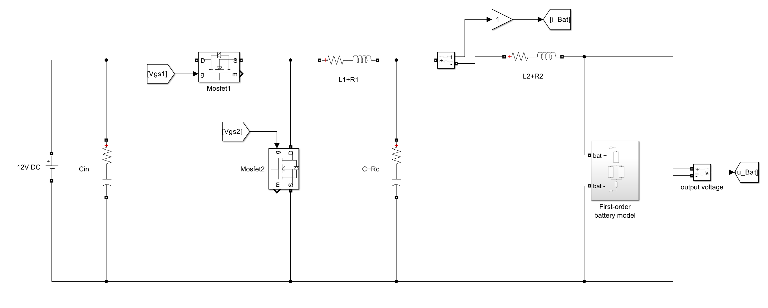
Figure 3-1 Main circuit module

3.2.2 System Control Module
The system control module is the core module of the simulation model. Its function is to invoke the PI control strategy and the AC/DC split control strategy in different frequency ranges, and send the duty-cycle commands it makes to the PWM modulation and gate driver part. With the current model, the control part has the low-frequency PI current control branch, the high-frequency AC/DC split branch, the control strategy switch unit, the PWM compare tool, and the gate drive voltage make unit. The main idea is when the AC shake frequency is low, a mix current loop of "DC reference current + AC reference current" is used right away; When the AC shake frequency goes up, the PI controller only keeps the DC work point, while the AC part is put straight into the power stage through duty cycle feed. The switch logic is same as the split control strategy talked about before. This way, the low-frequency part uses the closed-loop tracking capability of the PI controller, but the high-frequency part stops making the PI controller track a fast-changing AC part past its good range.
In the Simulink implementation, the control part output is keep inside the allowable duty-cycle range before it go to the PWM compare thing. This stop unrealistic duty-cycle commands when things change fast. Then the PWM compare thing make opposite switch signals for the two MOSFETs, and the gate-drive voltage part turn these logic signals into the gate-source voltage orders needed. So, the system control part link the math control strategy with the real switch action of the power circuit.

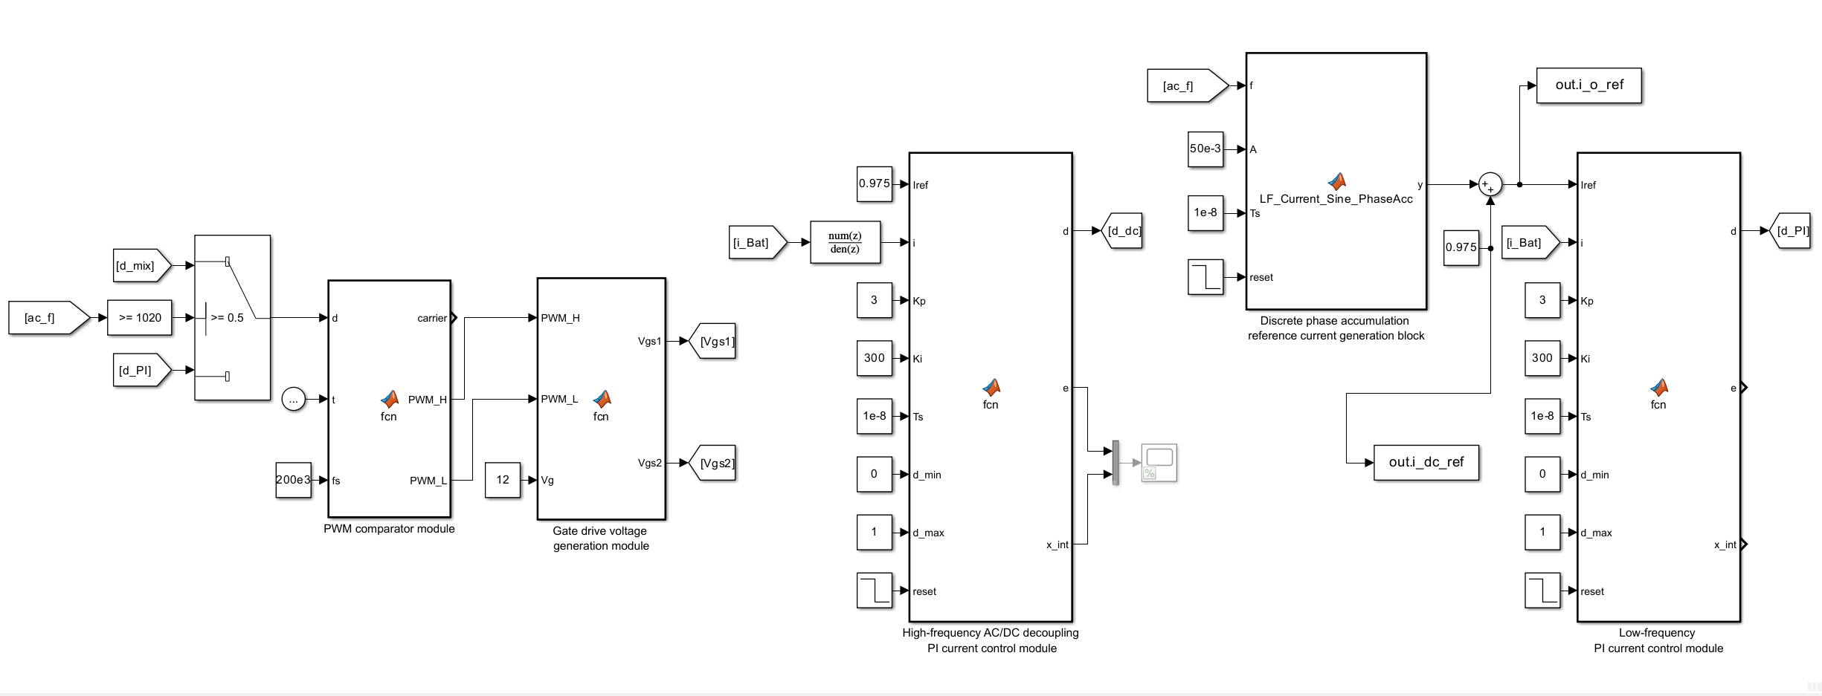
Figure 3-2 System Control module

3.2.3 AC Excitation Current Frequency and Related Parameter Generation Module
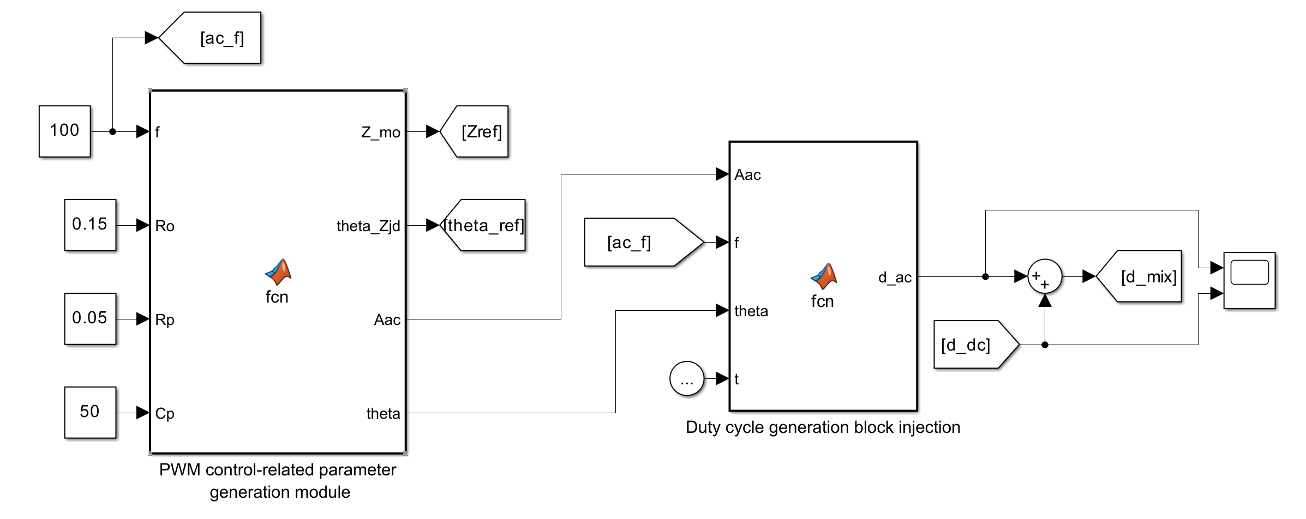
Figure 3-3 AC excitation current frequency and related parameter generation module
The AC excite current frequency and related parameter generation module is use to same manage measurement frequency and make stuff like theory impedance, target duty-cycle amplitude, and compensation phase that match current frequency. In combination with the current model structure, this part actually consists of two functional sub-modules: one is the excitation frequency generation module, and the other is the related parameter calculation module. The first one give now time frequency info to the control system and the impedance get part. The second one figure out the theory impedance and AC duty cycle feedforward at that frequency online use the battery circuit numbers and power stage numbers.
This part serves as a link between the control system and the impedance calculation process. For the low-frequency PI control part, the made frequency is used to build the AC current reference put on top of the DC charge current. For the high-frequency AC/DC polarization branch, the same frequency info is used to make the right duty-cycle shake and phase fix. So, the frequency make part make sure the shake signal, the control signal and the impedance extraction process all use the same target frequency.
For the theoretical impedance of the battery, the current model uses the first-order equivalent circuit for calculation, and its complex impedance, theoretical impedance modulus and impedance Angle expressions can be written as
$$\begin{aligned}\begin{aligned}\left\{\begin{aligned}ω = 2πf \\ Z_{ref\left(jω\right)}= R_{o}+\frac{R_{p}}{1 + jωR_{pC_{p}}} \\ Z_{ref}= \left|Z_{ref\left(jω\right)}\right| \\ θ_{ref}=\arg\left(Z_{ref\left(jω\right)}\right)\end{aligned}\right.\end{aligned}\#\left(3-16\right)\end{aligned}$$
These quantities are sent to the impedance calculation module as a reference benchmark for subsequent error calculations. The purpose of this processing is not to replace the measured values with theoretical ones, but to verify through a "theory-simulation" comparison whether the current control and measurement link can correctly restore the target frequency impedance characteristics.
In other words, the theoretical value is used only as a reference for model verification. If the measured impedance magnitude and phase are close to the theoretical reference under different excitation frequencies, it indicates that the current injection, voltage-current sampling and frequency-domain extraction processes are consistent. If a clear deviation appears, the error can be further traced back to the control bandwidth, switching ripple, sampling process or phase extraction process.

3.2.4 Impedance Calculation Module
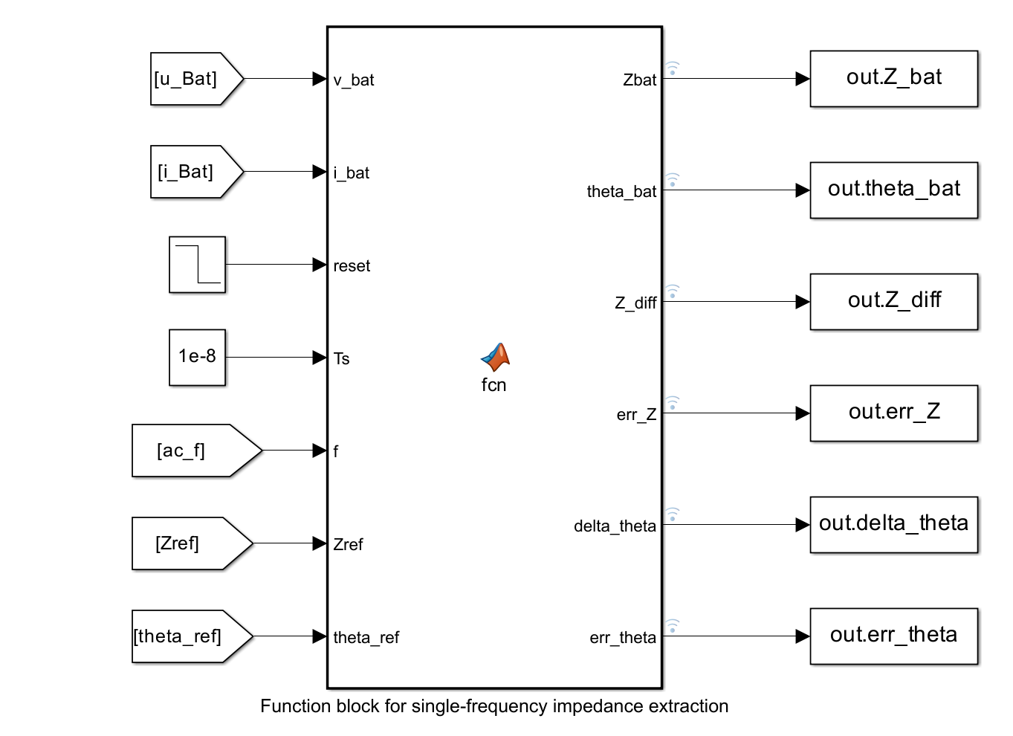
Figure 3-4 Impedance calculation module
The impedance calculation module is used to calculate the measured impedance mode and impedance Angle at the current frequency point based on the AC amplitude and phase information of the battery terminal voltage and current, and to compare and analyze them with the theoretical reference values.
To evaluate the simulation model 's ability to recover theoretical impedance, the impedance calculation module further provides impedance mode error and impedance Angle error, whose expressions are respectively
$$\begin{aligned}\begin{aligned}\left\{\begin{aligned}err_{Z}=\frac{\left|Z_{bat}- Z_{ref}\right|}{\left|Z_{ref}\right|}× 100\% \\ Δθ = \left|θ_{bat}- θ_{ref}\right| \\ err_{θ}=\frac{Δθ}{\left|θ_{ref}\right|}× 100\%\end{aligned}\right.\end{aligned}\#\left(3-17\right)\end{aligned}$$

In the actual calculation process, battery end voltage and current have both DC parts and AC shake parts. So the impedance extraction module try to get voltage and current parts at the target shake frequency, not use the full time-domain waveform. After get the size and angle info, the found impedance can be match with the theory impedance from the last part.
This part is also the main evaluation module for the sim. The out put impedance size, angle, size wrong and angle wrong can show if the pick control way is good for the current frequency point. For low frequency stuff, the wrong mainly show the PI current loop's track job. For high frequency stuff, the wrong is more close to how good the duty-cycle feedforward fix and the phase same of the put in AC current. So, the impedance figure part give the direct basis for looking at the sim results in Chapter 4.

Chapter 4 Simulation Results and Analysis

4.1 Control Strategy and Its Simulation Results
To check if the control way of the made embedded lithium battery EIS test system works, this paper do simulation for output current tracking capability and impedance measure accuracy of the system at different AC excitation frequencies, use the above main circuit model, part design results and control part. The simulation focused on the actual performance of two types of control methods, namely the tracking effect of the AC/DC hybrid reference current when using the PI control strategy in the low frequency band, and the output performance of the system in the high frequency band when introducing the AC/DC decoupling control strategy after the frequency exceeded the switching point.
This part aim not only see if the converter can keep the needed steady charging current, but also check if the small AC shake part can go into the battery with okay size and phase accuracy. For EIS check, the DC part sets the charge work point, while the AC part sets the quality of the impedance extraction. So, a control strategy that look steady in the time-domain current waveform may still give clear impedance wrong if the size or phase of the AC part is messed. This is big reason why the simulation analysis in this chapter think about both current follow and impedance count results.
To make the analysis results more targeted, this section mainly discusses the output current waveform, impedance mode error, and impedance angle error, and compares the applicable frequency bands and their advantages and disadvantages of the two control methods in combination with the simulation phenomena before and after the control strategy switching.
From the control strategy made in last part, the PI controller is big used for low-frequency check points, where the current loop still have enough follow power. When the shake speed get close to the switch speed, the tracking performance of the PI loop start to get bad. After the excitation frequency is higher than the designed switching point, the AC/DC decoupling strategy is adopted so that the DC charging component and the high-frequency AC injection component are processed separately. In this way, the following simulation results provide a direct comparison between the two control ideas and also verify whether the segmented control strategy is reasonable for the embedded EIS measurement system.

4.1.1 Simulation Results Based on the PI Control Strategy
When only the PI control strategy is used, the system output current is composed of the DC charging current and the AC excitation current, and the PI controller directly performs closed-loop tracking of the mixed reference current. Due to the high gain of the PI controller in the low-frequency range, the output current can follow the reference quantity well when the AC excitation frequency is low, and the current waveform is basically consistent with the set mixed reference current, indicating that the PI controller can simultaneously meet the control requirements of constant current charging and low-frequency impedance measurement at this time.
In this control way, the DC charge current and the sine excite current are superimposed before entering the current loop. So the PI controller does not distinguish between the charge part and the measure-impedance part. This build is simple and easy to do, good for a resource-limited microcontroller. But its work is very tied to the current-loop speed. If the excite frequency is a lot lower than the good speed of the current loop, the AC part can be followed okay. If the excitation frequency increases, the PI controller and the Buck power stage together introduce amplitude attenuation and phase delay, which will affect the subsequent impedance calculation.
(a) 10HzPI (b) 50HzPI
(c) 100HzPI (d) 250HzPI

(e) 500HzPI (f) 1kHzPI
Figure 4-1 Output current tracking waveforms based on PI control strategy at typical low and high frequency points
In Figure 4-1 (a), cause of the long time at 10 Hz, the impedance calculation module always give 0 before it get enough cycles, so you can see a step.
This thing happen from the way the single-frequency impedance extraction module count stuff, not from the PI control loop break. At low push like 10 Hz, one full signal time is kind of long, and the get module must throw away first rounds then pile up data over some full rounds before it give a steady impedance result. So, the first zero out and then the step-like change mostly show the wait and lock process of the impedance count module.
From the simulated waveforms we see, when the shake speed is in low part, the out power looks a lot like the reference current in both size and phase, so the system got good dynamic tracking capability in that part.
For 50 Hz and 100 Hz, the output current shape still close to the reference current. The DC work point stay around the constant-charge level, while the AC part is clear put on top of the current shape. This show that, in this freq range, the PI controller can still give sufficient control gain, and the converter output current can be used as a good excite signal for impedance measure. The impedance size error also keep at a pretty low level, which mean the voltage and current response at the target freq can be got with okay same.
But, when AC shake speed go up step by step, the good part of PI controller start to drop, and same time, the Buck power part's own high-frequency cut-down effect get more clear, so the output current's ability to follow the reference AC part get weak. When speed near the control strategy's change point, the output current start to show some amount wrong.
For the 250 Hz and 500 Hz cases, although the current waveform can still follow the reference in a general sense, the difference between the reference current and the actual output current becomes more visible than that at lower frequencies. This shows that the PI controller has not completely lost its tracking ability, but the margin of the control loop is gradually reduced. The influence of the converter dynamics also becomes more obvious, especially because the inductor, output capacitor and battery equivalent impedance jointly affect the high-frequency current distribution. As a result, the current component that actually flows into the battery is no longer only determined by the reference signal, but is also affected by the frequency-dependent characteristics of the power stage.
At 1 kHz, the shake speed is already near the plan change speed for control. In this case, the current shape still shows up and down, but the angle error for impedance gets way more clear. This result matches the frequency-domain analysis in the earlier part: close to the top edge of the PI control range, the close-loop gain and phase answer are not perfect. So, even if the PI plan can still keep the average charge current, it is not the best way for high-frequency EIS shake put-in.
To more check the impedance test under the PI control strategy, do impedance math on the AC voltage and current signals got at each frequency point. Then compare the impedance forms and impedance angles with theory reference numbers. The simulation results show that in the low-frequency range, both the impedance mode error and the impedance angle error remain at a low level, indicating that the system can accurately restore the impedance characteristics of the battery in this frequency band; However, when the excitation frequency increases, the increasing trend of impedance angle error is significantly faster than that of impedance mode error, indicating that the phase information is more sensitive to changes in control bandwidth and high-frequency dynamic characteristics.
This feature is important for the subsequent design of the control strategy. In EIS analysis, the impedance magnitude mainly reflects the ratio between the voltage and current amplitudes, while the impedance angle is related to the phase difference between the two signals. Compare to amplitude extraction, phase extraction is more touchy to sampling delay, control delay and high-frequency attenuation. So, even when the size wrong of impedance stay small, the angle wrong of impedance may go up first as the shake frequency go high. This tell why the PI control way is okay for low-frequency measurement but should not be used alone over the whole speed range.
Overall, the PI control sim results show the PI current loop works well for low-frequency EIS test part. It can keep DC charge current steady and let small AC shake go into the battery with okay tracking at low frequencies. But its problem get clear when the shake frequency go near kilohertz area. The drop in tracking accuracy, special the rise in phase error, give reason to bring in AC/DC separate control way in high-frequency part.

4.1.2 Simulation Results Based on the AC/DC Decoupling Control Strategy
For fix the problem of reduced tracking capability of PI control way in high frequency part, this paper put AC/DC decoupled control strategy into system and use near 1.02 kHz as switch frequency of control way. When AC excite frequency is lower than this number, system still use PI control way; when AC excite frequency is higher than this number, PI controller only do job for keep DC charging component steady, but AC excite part is put straight into power stage through duty cycle feedforward fix. By do this, the effect of PI controller band limit on high-frequency AC components can be made less, so make better amplitude-phase track accuracy of output current in high frequency part.
This part's simulation pick some frequency points higher than the switch frequency for compare, like 1.2 kHz, 1.5 kHz, 1.7 kHz and 2 kHz. These frequencies are in the range where PI control way start to show not good tracking, so they can better show the effect of using AC/DC decouple control method. In the wave compare, the DC reference current stay near the design constant-current charge level, but the AC part come from the extra duty-cycle shake. This mean the controller no more push the PI loop to follow a fast sine reference direct, but split the slow charge control from the high-freq excite making. So, the control job become more fit with the converter's move features.
(a) 1.2kHz (b) 1.5kHZ
(c) 1.7kHz (d) 2kHz
Figure 4-2 Output current tracking waveform based on AC/DC decoupling control strategy at typical high-frequency points
Table 4-1 Summary of impedance measurement results at selected frequency points
Frequency  / Hz | Control strategy | Measured |Z| / Ω | |Z| error  / Ω |  | |Z| relative error / % | Measured θ / ° | θ error / °
10 | PI | 0.16000 |  | 0.01000 | 6.67 | -0.07700 | 0.04500
50 | PI | 0.15230 |  | 0.00230 | 1.53 | -0.01900 | 0.00490
500 | PI | 0.14976 |  | -0.00024 | 0.16 | -0.00350 | 0.00100
1000 | PI | 0.14988 |  | -0.00012 | 0.08 | -0.00220 | 0.00100
1200 | AC/DC decoupling | 0.14993 |  | -0.000074 | 0.05 | 0.00340 | 0.00440
1700 | AC/DC decoupling | 0.14993 |  | -0.000071 | 0.05 | 0.00046 | 0.00120
2000 | AC/DC decoupling | 0.14994 |  | -0.000065 | 0.04 | 0.00015 | 0.00076

Look at Figure 4-2, the output current can still keep a clear sinusoidal waveform around the DC charge current at the picked high-freq points. When you compare with the high-freq PI control cases from Section 4.1.1, the current wave don't big use the closed-loop correction of the PI controller, but it come from the feedforward duty-cycle put in branch. So, the wave get less hit by the drop high-freq gain of the PI controller. The middle pictures in Figure 4-2 also show that the impedance size error stay at a pretty low level at these freq points. This indicates that the measured voltage and current amplitudes can still provide a reasonable basis for impedance modulus extraction after the control strategy is switched.
It should also be noted that the current waveform at high frequency is not completely identical to an ideal sinusoidal reference. This is mainly because the Buck power stage still contains switching ripple, inductor and capacitor dynamics, and parasitic resistance effects. In addition, the output capacitor branch can share part of the high-frequency AC component, so the battery-side current is affected not only by the duty-cycle perturbation itself, but also by the impedance relationship among the inductor, capacitor and battery branch. But from EIS measure view, big worry is if same-freq voltage and current parts can be got steady. Sim results show AC/DC split way can keep good high-freq push and give more stable impedance math results than just use PI control in this freq area.
Put together the two control ways test results, can see PI control way got simple structure, steady control and ease of implementation in low frequency part, and can do better job at tracking AC/DC mix reference current. So, it fit as control way for system low frequency measure time; in high frequency part, with bring in AC/DC decouple control way, system make better the output accuracy of AC excite signal in high frequency band by split DC control from AC put in, make the measure results of impedance mode and impedance Angle more near to theoretical reference values. Can see the split control way of "low-frequency PI control + high-frequency AC/DC decouple control" is feasible and effective. This way can think about the steadiness of constant current charge and the accuracy of wideband impedance measure, lay the foundation for later SOC guess and system experimental validation.
Also, at some freq points after use AC/DC decouple control way, there can be large percentage of impedance Angle wrong. This also need look at with the number range of the impedance Angle itself. When both the impedance Angle and the absolute value of the error of the lithium battery are small, the percentage of error is very sensitive to small fluctuations and is prone to numerical amplification. Therefore, the result is mathematically larger, but physically does not represent a significant decrease in measurement accuracy. In fact, from the impedance magnitude, the impedance angle waveform and its absolute deviation, the system out can still right show the actual impedance characteristics of the battery.
Overall, the sim results in this part more back the need for using a split control way. The PI controller stay because it good for keep the normal charge current and low-freq track. The AC/DC split branch is put in because it make better the control of high-freq shake without change the main charge work point. This result also show the said system not just a normal current-control charge circuit, but also a controllable perturbation-injection platform for built-in EIS measure. So, the control way give a real base for push the measurement frequency range to 2 kHz under the current sim conditions.

Chapter 5 Conclusion and Future Work

5.1 Conclusions
This paper focuses on the measurement method of electrochemical impedance spectroscopy for embedded lithium batteries. In view of the problems that traditional EIS measurement relies on dedicated equipment, is costly, has insufficient real-time performance and is difficult to be directly embedded in the battery management system, an online measurement idea based on power converter is proposed. This paper take the power part in lithium battery charging as research object, put the measure of impedance into the constant current charge step, and make together the AC injection, signal acquisition and impedance math by using same converter, sampling part and digital control resources. The results show this way give a good method for get lithium-ion battery impedance info online without big change the charge function. For system build, this work set up a embedded EIS measure plan where a two-way Buck/Boost converter do two jobs: charge power interface and AC shake source. Compared to use a outside shake source, this setup let use of old converters, control parts, and sample circuits more good, make it real fit for low-cost and small battery uses. The steady charge part is pick as main measure window because the work point stay more stable in this time, help put a small-signal AC current on top of the DC charge current. This give a more strong base for later impedance get.
This paper, in theory, look at small-signal stuff of a Buck-converter power thing for lithium batteries when doing EIS test. By put converter model with a simple first-order battery model, the link between duty cycle push and battery current answer is get. The work find that PI current control loop do good at low frequency, but its gain and phase get more tight when frequency go up. So, just one PI control not enough for wide EIS measure. To fix this, this paper use a split control way: PI control for mixed AC/DC current at low frequency, and a separate AC/DC duty cycle drive for high frequency. This control make AC current drive more stable and keep DC charging current same.
For setting numbers and making models, the big parts of the inside lithium battery EIS test system are set based on special needs about stopping current shake, getting sample right, shake frequency range, and getting impedance data. Then, a full MATLAB/Simulink model is built, with the main circuit, the system control part, the shake frequency and size settings, and the impedance get part. The simulation results show that, with PI control, the output current can follow the want current okay in the low frequency area, and the counted impedance size and angle are near the theory numbers. But, when the frequency goes up, the track error of the AC part gets more clear, special in the angle info. After put in the AC/DC split control strategy in the high frequency domain, the out AC current track work gets better, and the impedance count results get more close to the expected characteristics.
The sim results also show the percent error of the impedance angle should be interpreted carefully. When the real impedance angle is small, a little absolute phase change can cause a large percentage error. Therefore, impedance magnitude error, absolute phase deviation and waveform consistency should be considered together rather than relying only on the relative percentage error. This observation is important for evaluating the measurement performance of embedded EIS systems, because the physical meaning of the error is sometimes more useful than the numerical percentage alone.
Finally, this paper further discusses the potential use of impedance features for SOC estimation. Since the impedance magnitude and phase at different frequencies are related to the internal electrochemical state of the lithium battery, the embedded EIS measurement system developed in this study can provide feature-level support for SOC estimation. Even a complete SOC estimation model still requires further experimental data and calibration, but the simulation setup show that get impedance info from is technically feasible online. So, this paper work give base for later make SOC guess, battery health check and inside battery state monitoring methods.

5.2 Future Work
Future work can be carried out in three aspects. First, make and check the SOC guess model more, get the impedance number and angle of key frequencies under different SOC, temperature and aging states, and set the map link by using equivalent circuit parameter identification, feature regression or data-driven methods. In the present work, the simulation mainly verifies the feasibility of embedded EIS excitation and impedance extraction during constant current charging, but the relationship between the extracted impedance features and SOC has not yet been experimentally calibrated. Therefore, the next step should be to build a more complete impedance-SOC dataset. This dataset should include different SOC intervals, different ambient temperatures, and batteries with different aging levels, so that the influence of SOC can be distinguished from temperature drift and degradation effects. Also, pick special frequencies should not just use a fixed wideband sweep. Instead, find some frequency points from impedance spectrum that more show SOC change, like the frequency parts about ohmic resistance, charge-transfer process and polarization behavior. This can reduce unnecessary measurement points and make the guess model more useful in embedded uses.
For the modelling method, two routes can be further compared. The first route is to identify the parameters of an equivalent circuit model from the measured impedance data and then establish the relationship between these parameters and SOC. This method has clearer physical interpretability, because the identified resistance and polarization parameters can be related to the internal electrochemical state of the battery. The second way is to take impedance modulus, impedance angle, voltage, current and temperature as input variables and make a regression or machine-learning SOC estimation model. Compare with purely mechanism-based method, this method may have more strong fit power under nonlinear conditions, but it also need enough train data and careful check to stop overfitting. In future work, these two routes can be compared in terms of accuracy, robustness, computational cost and suitability for microcontroller implementation.
Second, make online measure work better, put in multi-frequency excitation, coherent multi-sine signals, Goertzel algorithm or synchronous detection methods to cut time for get spectrum. In now sim, get impedance at one frequency point per run, this help check control strategy and make sim less hard. But for real BMS, long single-freq sweep maybe not good cause battery state can change when measure. Future work should investigate faster measure ways. For example, a coherent multi-sine push can go into current ref or duty-cycle shake, and pick out answer at some target frequencies same time. Goertzel algorithm also good for put in resource-limited microcontrollers cause it can get chosen freq parts without do full FFT, this save memory and work. In addition, one should pay more attention to sampling rate, ADC bit number, window length, noise and switching ripple, as these factors directly affect the accuracy of the obtained impedance magnitude and phase.
The way to control thing still need more fix. Test show the split control way—use separate low-freq PI and high-freq AC/DC loops—can work, but the exact switch points and hysteresis bands must be check careful on different converter parts and battery states. In real digital controllers, stuff like PWM resolution, sample delays, gate drive delays, and signal fix may add extra phase errors. So, later study should add delay fix and tuning tricks—specially in the high-freq control part, which need more strict phase right. This make the whole control plan more strong from test to hardware use.
Finally, this work scope should get big past just one cell test to include real check, battery modeling, and system-level look at the battery pack level. Also, machine learning or light guess methods should be put in to help full system watch, fault find (like find old-related faults), and heat work warnings. For hardware build, a test board using STM32 chip could be made to check if the way works good during real battery charge times. The first test platform should include the buck/boost buck-boost power supply part, MOSFET driver, current detection circuit, voltage detection circuit and digital signal processing program. The measured impedance results should be compared with those obtained from a commercial EIS instrument or a reference test platform, so that the measurement error of the embedded system can be quantitatively evaluated. This validation is important because the simulation model cannot fully represent non-ideal effects such as component tolerance, parasitic inductance, sensor offset, switching noise and thermal variation.
After the single-cell experiment is completed, the work can be extended to battery modules and battery packs. In this case, the research focus will not only be the impedance measurement accuracy of one cell, but also the consistency differences among cells. The SOC and impedance estimation results can use to spot cells with severe aging, high internal resistance or poor consistency. Also, the estimated SOC can mix with balance control to cut down imbalance during charge and make pack better. For longer time, impedance features may also join with temperature and voltage data to help SoH guess and early warn of abnormal thermal behaviour. But, these jobs should grow step by step, start from stable one-cell measure, then go to module-level check, and last think about full battery-pack applications.

5.3 Reflection
Through the research and writing of this topic, the author's understanding of the embedded lithium battery EIS measurement system has gradually deepened from the conceptual level to the system level. The research covered not only lithium battery equivalent modeling, power electronic converter analysis and closed-loop control theory, but also frequency-domain signal extraction, impedance calculation and simulation system construction. The entire research process shows that embedded battery state awareness is not a problem of a single module, but rather the result of the coupling of power circuits, control strategies, sampling links and signal processing methods. It is in this process that the author gradually realizes that engineering problems often require the coordinated advancement of multiple levels from “model - control - implementation - verification” in order to reach more reliable conclusions.
During the progress of this project, some limitations in the early planning and experimental design were also exposed. At the beginning of the work, the difficulty of high-frequency impedance measurement was not fully understood. In particular, the influence of switching ripple, current-loop bandwidth, sampling accuracy and circuit parasitic effects on impedance extraction was underestimated. As a result, some parts of the simulation model and result analysis had to be corrected repeatedly during later debugging. This process made the author realize that an embedded EIS measurement system cannot be evaluated only from the viewpoint of whether the circuit can operate normally. It is also necessary to judge whether the injected small-signal current can be accurately maintained and whether the voltage and current response at the target frequency can be reliably extracted.
Another important reflection concerns the interpretation of simulation results. In the early stage, the author tended to focus mainly on percentage error when evaluating the impedance magnitude and impedance angle. However, during the analysis of the results, it became clear that the percentage error of the impedance angle may be numerically amplified when the actual impedance angle is very small. So, evaluate impedance measurement performance should not just use one number. Must look at the error value, waveform consistency, theoretical reference value and physical interpretation together. This helped the author get a more careful idea about simulation data and stop get one-sided conclusions from single numerical indicators.
The project also show big need for modular build and step-by-step check. When main circuit, PI control part, AC/DC polar branch, excite make part and impedance count module were put together as a full system, debug got hard cause mistakes from different bits could mess with each other. A better way was to check each part alone under simple settings, then slowly link the parts while watch the output current, battery end voltage and counted impedance. This way made the simulation process easier to trace and also made the author better at breaking a hard engineering problem into small testable jobs.
Finally, this work let the author see more clear the hole between a perfect model and a real hardware thing. Theoretical analysis helps clarify how duty-cycle change, battery current and impedance link together, but real hardware still need think about sensor noise, ADC bits, PWM resolution, computational resources, sampling synchronisation, heat and board layout. So, if this work go on later, more focus should put on experimental validation, online calibration and robustness analysis under different operating conditions. Overall, this project provided useful training in combining power electronics, control theory and signal processing, and also showed that a reliable engineering solution requires not only correct modelling, but also careful implementation planning and repeated verification.

References and Bibliography
[1] K. McCarthy, H. Gullapalli, K. M. Ryan, and T. Kennedy, “Review—Use of Impedance Spectroscopy for the Estimation of Li-Ion Battery State of Charge, State of Health and Internal Temperature,” J. Electrochem. Soc., vol. 168, no. 8, p. 080517, 2021.
[2] P. Hu, C. Y. Li, and C. C. Lee, “SoC Estimation of Lithium-Ion Batteries Utilizing EIS Technology with SHAP–ASO–LightGBM,” Batteries, vol. 11, no. 7, p. 272, 2025.
[3] J. Lourenco, L. S. Rosado, P. M. Ramos, and F. M. Janeiro “Measurement of Battery Aging Using Impedance Spectroscopy with an Embedded Multisine Coherent Measurement System,” Batteries, vol. 11, no. 6, p. 227, 2025. The DOI: 10.3390 / batteries11060227
[4] G. Cicioni, A. De Angelis, F. M. Janeiro, P. M. Ramos, and P. Carbone, “Battery Impedance Spectroscopy Embedded Measurement System,” Batteries, vol. 9, no. 12, p. 577, 2023.
[5] A. Blomeke et al., "Balancing Resize-based online electrochemical impedance spectroscopy in battery systems: opportunities and limitations,” Communications Engineering (Nature), vol. 3, art. 62, 2024.
[6] M. Kuipers et al., “An algorithm for an online electrochemical impedance spectroscopy and battery parameter estimation: development, verification and validation,” J. Energy Storage, vol. 30, p. 101517, 2020.
[7] M. Galeotti et al., “Performance analysis and SOH evaluation of lithium polymer batteries through electrochemical impedance spectroscopy,” Energy, vol. 89, pp. 678–686, 2015.
[8] X. Hu, C. Zou, C. Zhang, and Y. Li, “Technological Developments in Batteries: A Survey of Principal Roles, Types, and Management Needs,” IEEE Power Energy Mag., vol. 15, no. 5, pp. 20–31, 2017.
[9] R. Xiong, J. Cao, Q. Yu, H. He, and F. Sun, “Critical review on the battery state of charge estimation methods for electric vehicles,” IEEE Access, vol. 6, pp. 1832–1843, 2018.
[10] L. Regnacq, Y. Wu, N. Neshatvar, D. Jiang, and A. Demosthenous, “A Goertzel filter-based system for fast simultaneous multi-frequency EIS,” IEEE Trans. Circuits Syst. II: Express Briefs, vol. 68, no. 9, pp. 3133–3137, 2021.
[11] A. De Angelis, E. Buchicchio, F. Santoni, A. Moschitta, and P. Carbone, “Uncertainty characterization of a practical system for broadband measurement of battery EIS,” IEEE Trans. Instrum. Meas., vol. 71, art. no. 1002609, 2022.
[12] P. Eleftheriadis, S. Giazitzis, S. Leva, and E. Ogliari, “Transfer Learning Techniques for the Lithium-Ion Battery State of Charge Estimation,” IEEE Access, vol. 12, pp. 993–1004, 2024.
[13] B. Schweighofer, K. M. Raab, and G. Brasseur, “Modeling of High-Power Automotive Batteries by the Use of an Automated Test System,” IEEE Trans. Instrum. Meas., vol. 52, no. 4, pp. 1087–1091, 2003.
[14] M. Chen and G. A. Rincon-Mora “Accurate electrical battery model capable of predicting runtime and I–V performance,” IEEE Trans. Energy Convers., vol. 21, no. 2, pp. 504–511, 2006.
[15] X. Hu, S. E. Li, and Y. Yang, “Advanced Machine Learning Approach for Lithium-Ion Battery State Estimation in Electric Vehicles,” IEEE Trans. Transp. Electrific., vol. 2, no. 2, pp. 140–149, 2016.
[16] Y. Liu, X. Hu, X. Li, and S. E. Li, “A Novel Adaptive H-Infinity Filtering Method for Accurate SOC Estimation of Lithium-Ion Batteries,” IEEE Trans. Veh. Technol., vol. 69, no. 8, pp. 8275–8283, 2020.
[17] Y. Zhang, R. Xiong, H. He, and M. Pecht, “Long Short-Term Memory Networks for Lithium-Ion Battery Health Prognostics,” IEEE Trans. Instrum. Meas., vol. 66, no. 9, pp. 2287–2297, 2017.
[18] C. Lee and S. Kim, “On-Line State of Health Estimation of Lithium-Ion Battery Using Unscented Particle Filter,” IEEE Access, vol. 6, pp. 86578–86587, 2018.
[19] Y. Li, H. Guo, F. Qi, Z. Guo, and M. Li, “Comparative Study of Open-Circuit Voltage Test Influence on State of Charge Estimation for Lithium-Ion Batteries,” IEEE Access, vol. 9, pp. 5250–5259, 2021.
[20] X. Liu, Y. Wang, J. Chen, and C. Zhang, “State-of-Charge Estimation of Lithium-Ion Battery Based on an Extended H-Infinity Filter,” in Proc. IEEE Int. Conf. Ind. Informatics (INDIN), 2019, pp. 1010–1015.

Appendix A. Function Block Code
Function Block 1: PWM Comparator Module
function [carrier, PWM_H, PWM_L] = fcn(d, t, fs)
% PWM comparator module
% Inputs:
% d - Duty cycle input, expected range 0~1
% t - Current simulation time
% fs - Switching frequency
%
% Outputs:
% carrier - Normalized sawtooth carrier, range 0~1
% PWM_H - High-side PWM output (0 or 1)
% PWM_L - Low-side PWM output (0 or 1)

% Prevent abnormal inputs
if d > 1
d_use = 1;
elseif d < 0
d_use = 0;
else
d_use = d;
end

% Prevent invalid frequency
if fs <= 0
carrier = 0;
PWM_H = 0;
PWM_L = 1;
return;
end

% PWM period
T_pwm = 1 / fs;

% Normalized sawtooth carrier: linearly rises from 0 to nearly 1 in each period
carrier = mod(t, T_pwm) / T_pwm;

% Compare to obtain the high-side PWM
if d_use >= carrier
PWM_H = 1;
else
PWM_H = 0;
end

% Ideal complementary low-side PWM
PWM_L = 1 - PWM_H;
end

Function Block 2: Gate Drive Voltage Generation Module
function [Vgs1, Vgs2] = fcn(PWM_H, PWM_L, Vg)
% Gate drive voltage generation module
% Inputs:
% PWM_H - High-side PWM (recommended input: 0 or 1)
% PWM_L - Low-side PWM (recommended input: 0 or 1)
% Vg - Gate-source drive voltage amplitude, for example 12 V
%
% Outputs:
% Vgs1 - Gate-source drive voltage of S1
% Vgs2 - Gate-source drive voltage of S2

% Limit the high-side PWM to 0~1
if PWM_H >= 0.5
h = 1;
else
h = 0;
end

% Limit the low-side PWM to 0~1
if PWM_L >= 0.5
l = 1;
else
l = 0;
end

% Drive amplitude protection
if Vg < 0
Vg_use = 0;
else
Vg_use = Vg;
end

% Output gate-source voltage
Vgs1 = h * Vg_use;
Vgs2 = l * Vg_use;
end

Function Block 3: High-frequency AC/DC Decoupling PI Current Control Module
function [d, e, x_int] = fcn(Iref, i, Kp, Ki, Ts, d_min, d_max, reset)
% High-frequency AC/DC decoupling PI current control module
% Inputs:
% Iref - Reference current
% i - Actual current
% Kp - Proportional coefficient
% Ki - Integral coefficient
% Ts - Sampling period
% d_min - Lower duty cycle limit
% d_max - Upper duty cycle limit
% reset - Reset signal
%
% Outputs:
% d - Duty cycle output
% e - Current error
% x_int - Integral state

persistent int_e

if isempty(int_e)
int_e = 0;
end

if reset > 0.5
int_e = 0;
end

% Current error
e = Iref - i;

% Integral term
int_e = int_e + e * Ts;

% PI output
d = Kp * e + Ki * int_e;

% Duty cycle saturation
if d > d_max
d = d_max;
elseif d < d_min
d = d_min;
end

% Output integral state
x_int = int_e;
end

Function Block 4: Discrete Phase Accumulation Reference Current Generation Block
function y = LF_Current_Sine_PhaseAcc(f, A, Ts, reset)
% Discrete phase accumulation reference current generation block
% Inputs:
% f - Current frequency (Hz)
% A - Sine amplitude (A)
% Ts - Sampling period (s)
% reset - Reset signal (phase is cleared when >0.5)
%
% Outputs:
% y - Low-frequency AC reference current

persistent theta

% Initialization
if isempty(theta)
theta = 0;
end

% Input protection
if f < 0
f_use = 0;
else
f_use = f;
end

if A < 0
A_use = 0;
else
A_use = A;
end

if Ts <= 0
y = 0;
return;
end

% Reset: clear the phase and restart from the zero point
if reset > 0.5
theta = 0;
y = 0;
return;
end

% Output the sine value corresponding to the current phase
y = A_use * sin(theta);

% Phase recursion
theta = theta + 2*pi*f_use*Ts;

% Constrain the phase to [-pi, pi] to prevent numerical growth
if theta > pi
theta = theta - 2*pi;
elseif theta < -pi
theta = theta + 2*pi;
end
end

Function Block 5: Low-frequency PI Current Control Module
function [d, e, x_int] = fcn(Iref, i, Kp, Ki, Ts, d_min, d_max, reset)
% Low-frequency PI current control module
% Inputs:
% Iref - Reference current
% i - Actual current
% Kp - Proportional coefficient
% Ki - Integral coefficient
% Ts - Sampling period
% d_min - Lower duty cycle limit
% d_max - Upper duty cycle limit
% reset - Reset signal
%
% Outputs:
% d - Duty cycle output
% e - Current error
% x_int - Integral state

persistent int_e

if isempty(int_e)
int_e = 0;
end

if reset > 0.5
int_e = 0;
end

% Current error
e = Iref - i;

% Integral term
int_e = int_e + e * Ts;

% PI output
d = Kp * e + Ki * int_e;

% Duty cycle saturation
if d > d_max
d = d_max;
elseif d < d_min
d = d_min;
end

% Output integral state
x_int = int_e;
end

Function Block 6: PWM Control-related Parameter Generation Module
function [Z_mo, theta_Zjd, Aac, theta] = fcn(f, Ro, Rp, Cp)
% PWM control-related parameter generation module
% Inputs:
% f - AC excitation current frequency
% Ro - Ohmic internal resistance of the first-order equivalent circuit
% Rp - Polarization resistance of the first-order equivalent circuit
% Cp - Polarization capacitance of the first-order equivalent circuit
%
% Outputs:
% Z_mo - Impedance magnitude of the first-order equivalent circuit
% theta_Zjd - Impedance angle of the first-order equivalent circuit (degrees)
% Aac - Duty cycle signal amplitude
% theta - Duty cycle signal phase (radians)

w = 2*pi*f;

% Impedance calculation of the first-order equivalent circuit
X_c = 1/(w*Cp*1i);
Z = Ro + (Rp*X_c)/(Rp + X_c); % Impedance of the first-order equivalent circuit

Z_mo = abs(Z); % Impedance magnitude of the first-order equivalent circuit
theta_Zrad = angle(Z); % Impedance angle of the first-order equivalent circuit (radians)
theta_Zjd = theta_Zrad*180/pi; % Impedance angle of the first-order equivalent circuit (degrees)

% The following formulas are used for the target duty cycle function under high-frequency conditions
L1 = 100e-6; % Inductor 1
R1 = 0.1;
L2 = 15e-6; % Inductor 2
R2 = 16e-3;
C = 220e-6; % Output capacitor
Rc = 0.5;
Iac = 0.05; % Amplitude of the AC disturbance reference current
Ui = 12; % Input voltage

m1 = (w*(L1+L2)*Iac)/(Ui);
m2 = w*w*L1*C*((w*L2*Iac - w*Rc*R2*C*Iac)/((1 + w*w*C*C*Rc*Rc)*Ui));
m3 = w*R1*C*((w*w*Rc*L2*C*Iac + R2*Iac)/((1 + w*w*Rc*Rc*C*C)*Ui));
m = m1 - m2 + m3;

n1 = (R1+R2)*Iac/Ui;
n2 = w*w*L1*C*((w*w*Rc*L2*C*Iac + R2*Iac)/((1 + w*w*C*C*Rc*Rc)*Ui));
n3 = w*R1*C*((w*L2*Iac - w*Rc*R2*C*Iac)/((1 + w*w*C*C*Rc*Rc)*Ui));
n = n1 - n2 - n3;

Aac = sqrt(m^2 + n^2);

if n < 0
theta = atan(m/n) + pi;
else
theta = atan(m/n);
end

Function Block 7: Duty Cycle Injection Generation Block
function d_ac = fcn(Aac, f, theta, t)
% Duty cycle injection generation block
% Inputs:
% Aac - Amplitude of the AC duty cycle component
% f - AC excitation frequency
% theta - Phase of the AC duty cycle component (radians)
% t - Current system time
%
% Outputs:
% d_ac - AC duty cycle signal

d_ac = Aac * sin(2*pi*f*t + theta);
end

Function Block 8: Single-frequency Impedance Extraction Block
function [Zbat, theta_bat,Z_diff, err_Z, delta_theta, err_theta ] = fcn(v_bat, i_bat, reset, Ts, f, Zref, theta_ref)
% Function block for single-frequency impedance extraction (reference error calculation + Z_diff output)
% Inputs:
% v_bat - Battery terminal voltage (original time-domain signal, including DC + AC)
% i_bat - Battery terminal current (original time-domain signal, including DC + AC)
% reset - Reset signal, 1 = clear and wait, 0 = start measurement
% Ts - Discrete time step
% f - Current excitation frequency (Hz)
% Zref - Reference impedance magnitude
% theta_ref - Reference impedance angle (degrees)
%
% Outputs:
% Zbat - Measured impedance magnitude
% theta_bat - Measured impedance angle (degrees)
% err_Z - Percentage error of impedance magnitude
% delta_theta - Absolute error of impedance angle (degrees)
% err_theta - Percentage error of impedance angle
% Z_diff - Impedance magnitude difference Zbat - Zref
%
% Notes:
% 1) Use single-frequency synchronous detection to extract directly from the original v_bat and i_bat
% 2) Clear and wait when reset = 1
% 3) After reset is pulled low, discard several cycles first, then measure over integer cycles
% 4) After one measurement, latch and hold the result until the next reset or frequency change
% 5) Calculate the errors in real time according to the input Zref and theta_ref

% =========================
% Adjustable parameters
% =========================
N_cycle_ignore = 1; % Number of cycles discarded before measurement starts
N_cycle_measure = 6; % Number of cycles actually used for measurement
Iamp_min = 1e-8; % Minimum AC current threshold to prevent division by zero
eps_val = 1e-12; % Small-value threshold

% =========================
% Persistent variables
% =========================
persistent phi
persistent cycle_count
persistent meas_done
persistent f_last

persistent sum_v sum_i
persistent sum_vs sum_vc
persistent sum_is sum_ic
persistent sum_s sum_c
persistent N

persistent Z_hold theta_hold
persistent errZ_hold dtheta_hold errtheta_hold
persistent Zdiff_hold

if isempty(phi)
phi = 0;
cycle_count = 0;
meas_done = 0;
f_last = 0;

sum_v = 0;
sum_i = 0;
sum_vs = 0;
sum_vc = 0;
sum_is = 0;
sum_ic = 0;
sum_s = 0;
sum_c = 0;
N = 0;

Z_hold = 0;
theta_hold = 0;
errZ_hold = 0;
dtheta_hold = 0;
errtheta_hold = 0;
Zdiff_hold = 0;
end

% Default output keeps the last valid value
Zbat = Z_hold;
theta_bat = theta_hold;
err_Z = errZ_hold;
delta_theta = dtheta_hold;
err_theta = errtheta_hold;
Z_diff = Zdiff_hold;

% Invalid input protection
if (Ts <= 0) || (f <= 0)
Zbat = 0;
theta_bat = 0;
err_Z = 0;
delta_theta = 0;
err_theta = 0;
Z_diff = 0;
return;
end

% When reset is active: clear all states and wait
if reset > 0.5
phi = 0;
cycle_count = 0;
meas_done = 0;
f_last = f;

sum_v = 0;
sum_i = 0;
sum_vs = 0;
sum_vc = 0;
sum_is = 0;
sum_ic = 0;
sum_s = 0;
sum_c = 0;
N = 0;

Z_hold = 0;
theta_hold = 0;
errZ_hold = 0;
dtheta_hold = 0;
errtheta_hold = 0;
Zdiff_hold = 0;

Zbat = 0;
theta_bat = 0;
err_Z = 0;
delta_theta = 0;
err_theta = 0;
Z_diff = 0;
return;
end

% If the frequency changes, restart the measurement for this frequency point
if abs(f - f_last) > max(eps_val, 1e-9 * max(1, abs(f_last)))
phi = 0;
cycle_count = 0;
meas_done = 0;
f_last = f;

sum_v = 0;
sum_i = 0;
sum_vs = 0;
sum_vc = 0;
sum_is = 0;
sum_ic = 0;
sum_s = 0;
sum_c = 0;
N = 0;

Z_hold = 0;
theta_hold = 0;
errZ_hold = 0;
dtheta_hold = 0;
errtheta_hold = 0;
Zdiff_hold = 0;

Zbat = 0;
theta_bat = 0;
err_Z = 0;
delta_theta = 0;
err_theta = 0;
Z_diff = 0;
end

% If the measurement has been completed, directly hold the output
if meas_done > 0.5
Zbat = Z_hold;
theta_bat = theta_hold;
err_Z = errZ_hold;
delta_theta = dtheta_hold;
err_theta = errtheta_hold;
Z_diff = Zdiff_hold;
return;
end

% =========================
% Single-frequency synchronous detection
% Read the reference first, then advance the phase
% =========================
ref_sin = sin(phi);
ref_cos = cos(phi);

% Start accumulation only after the ignored cycles have ended
if cycle_count >= N_cycle_ignore
sum_v = sum_v + v_bat;
sum_i = sum_i + i_bat;

sum_vs = sum_vs + v_bat * ref_sin;
sum_vc = sum_vc + v_bat * ref_cos;

sum_is = sum_is + i_bat * ref_sin;
sum_ic = sum_ic + i_bat * ref_cos;

sum_s = sum_s + ref_sin;
sum_c = sum_c + ref_cos;

N = N + 1;
end

% Advance the phase
phi = phi + 2*pi*f*Ts;

% Count using complete cycles
while phi >= 2*pi
phi = phi - 2*pi;
cycle_count = cycle_count + 1;
end

% =========================
% After reaching the specified measurement cycles, calculate once and latch
% =========================
if (cycle_count >= (N_cycle_ignore + N_cycle_measure)) && (N > 0)

% ---- Explicitly remove DC leakage ----
mean_v = sum_v / N;
mean_i = sum_i / N;

Vsin = 2 * (sum_vs - mean_v * sum_s) / N;
Vcos = 2 * (sum_vc - mean_v * sum_c) / N;

Isin = 2 * (sum_is - mean_i * sum_s) / N;
Icos = 2 * (sum_ic - mean_i * sum_c) / N;

% ---- Amplitude ----
Vamp = sqrt(Vsin*Vsin + Vcos*Vcos);
Iamp = sqrt(Isin*Isin + Icos*Icos);

% ---- Phase ----
theta_v = atan2(Vcos, Vsin);
theta_i = atan2(Icos, Isin);

% ---- Impedance ----
if Iamp > Iamp_min
Z_hold = Vamp / Iamp;
theta_hold = (theta_v - theta_i) * 180 / pi;
else
Z_hold = 0;
theta_hold = 0;
end

% Limit the phase angle to [-180, 180]
while theta_hold > 180
theta_hold = theta_hold - 360;
end
while theta_hold < -180
theta_hold = theta_hold + 360;
end

% ---- Impedance magnitude difference ----
Zdiff_hold = Z_hold - Zref;

% =========================
% Error calculation
% =========================

% Percentage error of impedance magnitude
if abs(Zref) > eps_val
errZ_hold = abs(Z_hold - Zref) / abs(Zref) * 100;
else
errZ_hold = 0;
end

% Absolute phase angle error (considering angle wrapping)
angle_diff = theta_hold - theta_ref;
while angle_diff > 180
angle_diff = angle_diff - 360;
end
while angle_diff < -180
angle_diff = angle_diff + 360;
end
dtheta_hold = abs(angle_diff);

% Percentage error of phase angle
if abs(theta_ref) > eps_val
errtheta_hold = dtheta_hold / abs(theta_ref) * 100;
else
errtheta_hold = 0;
end

% Latch completed
meas_done = 1;
end

% Output latched values
Zbat = Z_hold;
theta_bat = theta_hold;
err_Z = errZ_hold;
delta_theta = dtheta_hold;
err_theta = errtheta_hold;
Z_diff = Zdiff_hold;

end

Appendix B. Progress Journal
